Affiliated to Pokhara University
POKHARA ENGINEERING COLLEGE

Phirke, Pokhara-8

A
Project Report on
"HomeGuard: An Intelligent Home Surveillance System"
Submitted by:
DIKCHHYA THAPA (22070450)
PRAKRITI ADHIKARI (22070456)
RONIKA RUMBA (22070459)
SADIKSHYA SUBEDI (22070460)

Supervisor:
ER. RAMESH MANDAL
Submitted to:
Research Management Cell
Pokhara Engineering College
2026
Date: ……………………………
CERTIFICATE OF APPROVAL
The project entitled "HomeGuard: An Intelligent Home Surveillance System" proposed by the students Dikshya Thapa (2020450), Prakriti Adhikari (2020456), Sadikshya Subedi (20204589), Ronika Rumba (2020460), of Pokhara Engineering College, under the Department of Computer Engineering, has been prepared in the standard format proposed by the Research Management Cell. The project report has been found feasible and is not submitted elsewhere for the award of any other degree, and is thus accepted.
……………………………
Assistant Prof. Er. Ramesh Mandal
Project Supervisor
……………………………
Assistant Prof. Er. Krishna Ghimire
Coordinator, Research Management Cell
……………………………
Assistant Prof. Er. Suraj Basant Tulachan
Head of Computer Engineering Department

……………………………
Assistant Prof. Dr.Bidur Devkota
External Examiner, GCES
ACKNOWLEDGEMENT
We would like to express our sincere gratitude to everyone who supported us throughout the development of this project, “HomeGuard: An Intelligent Home Surveillance System”, submitted in partial fulfillment of the requirements for the Bachelor's Degree in Computer Engineering awarded by Pokhara University.
We are deeply thankful to our project supervisor, Er. Ramesh Mandal, for his continuous guidance, technical insight, and constructive feedback throughout every stage of this project from initial design decisions to the resolution of integration challenges between the backend and AI engine. His mentorship was instrumental in shaping both the architecture and the final outcome of this system.
We also extend our gratitude to Er. Suraj Basant Tulachan, Head of the Department of Computer Engineering, and Er. Krishna Ghimire, Coordinator of the Research Management Cell, for their support and coordination throughout our academic journey. Our thanks also go to the wider faculty of Pokhara Engineering College for fostering an environment that encouraged independent, in-depth project work.
Finally, we thank our families and classmates for their patience, encouragement, and support during the long hours of development and testing, and everyone else who, directly or indirectly, contributed to the successful completion of this project.

ABSTRACT
Residential security has become an increasing concern as homeowners spend more time away from home, while traditional CCTV systems remain largely passive, generating large volumes of footage and frequent false alerts triggered by pets, lighting changes, or routine movement. Advances in AI-driven computer vision have opened the way for more intelligent, identity-aware home security solutions that move beyond passive recording toward selective, meaningful event detection.
This project presents HomeGuard, an intelligent home surveillance system built as two cooperating services: a Django REST backend structured using Clean Architecture principles, and a Python/FastAPI AI engine responsible for real-time human detection, multi-object tracking, and face recognition, together with a web-based dashboard for monitoring and managing household security. Users are organized around a home-centric hierarchy in which each Home has an owner and multiple members assigned distinct roles: OWNER, ADMIN, MEMBER, GUEST, and SECURITY, with permissions such as door-unlock rights attached to roles rather than to individual users.
The system identifies registered household members and unknown individuals using YOLOv8, ByteTrack, and InsightFace, generating structured detection events to reduce false alerts. A separate Celery-based smart-lock workflow performs asynchronous face verification for door access without blocking web requests, while the Django backend independently generates alerts based on the home's security mode. Two locally hosted language models via Ollama provide automatic event summaries and a conversational interface for querying surveillance history.
Keywords: HomeGuard, Intelligent Home Surveillance, Artificial Intelligence, Computer Vision, Object Detection, Face Recognition, Django REST Framework, Clean Architecture, Role-Based Access Control (RBAC), Smart Lock.

TABLE OF CONTENTS

CERTIFICATE OF APPROVAL i
ACKNOWLEDGEMENT ii
ABSTRACT iii
TABLE OF CONTENTS iv
LIST OF FIGURES vii
LIST OF TABLES viii
ABBREVIATIONS ix
Chapter 1: Introduction 0
1.1 Background 0
1.2 Problem Statement 0
1.3 Objectives 1
1.4 Project Scope 1
1.5 Limitations 2
Chapter 2: Literature Review 3
2.1 Evolution from Passive CCTV to AI-Based Surveillance 3
2.2 Object Detection and Multi-Object Tracking 3
2.3 Face Recognition for Identity-Aware Access 3
2.4 Event-Based Architectures and Session Modeling 4
2.5 Role-Based Access Control in Smart-Home Systems 4
2.6 Privacy, Security, and Ethical Considerations 5
2.7 Comparative Summary of Reviewed Literature 5
2.8 Research Gap 6
2.9 Comparison with Existing Home Surveillance Systems 8
Chapter 3: System Analysis and Design 9
3.1 Development Methodology 9
3.2 Requirement Analysis 9
3.2.1 Functional Requirements 9
3.2.2 Non-Functional Requirements 10
3.3 Feasibility Analysis 11
3.3.1 Technical Feasibility 11
3.3.2 Operational Feasibility 11
3.3.3 Economic Feasibility 12
3.3.4 Schedule Feasibility 12
3.4 System Architecture 13
3.4.1 Django Backend (Clean Architecture) 16
3.4.2 FastAPI AI Engine 16
3.5 Data Model Design 16
3.6 Role-Based Access Control 18
3.7 Use Cases 19
3.8 AI Detection and Smart-Lock Access Flow 21
3.9 Security and Privacy Measures 24
Chapter 4: Implementation 25
4.1 Technology Stack 25
4.2 Backend Module Implementation 25
4.2.1 Home and Membership Management 25
4.2.2 Device Registration and Health 26
4.2.3 Face Enrollment 26
4.2.4 Detection Event Lifecycle 26
4.2.5 Smart-Lock Verification Flow 27
4.2.6 Per-Home Scoping of Face Matching 27
4.3 Web Dashboard 28
4.4 Chat Assistant and Automated Event Summarization 28
Chapter 5: Testing and Results 29
5.1 Functional Testing 29
5.2 Integration Testing 30
5.3 System (End-to-End) Testing 30
5.4 Security Testing 31
5.5 Negative Testing 32
5.6 Discussion 32
6.1 Conclusion 33
6.2 Future Work 34
References 36
Appendices 38
Appendix A: System User Interface Screenshots 38
Figure A.1: HomeGuard Account Registration View 38
Figure A.2: HomeGuard Authentication View 38
Figure A.3: Household Selection & Setup Panel 39
Figure A.4a: Dashboard Header, AI Assistant & Security Modes 39
Figure A.4b: Dashboard Lower Feed & Live Surveillance 40
Figure A.4c: Dashboard Real-Time Identity Scanning State for Smart Lock 40
Figure A.5: User Face Enrollment Screen 41
Figure A.6: HomeGuard Household Members Directory View 41
Figure A.7: HomeGuard Device Directory View 42
Figure A.8: Device Detail View 42
Figure A.9: Member Profile & Access Management Detail 43
Figure A.10: HomeGuard Activity Timeline Feed View 43
Figure A.11: HomeGuard Live Event Processing & Analysis Modal 44
Figure A.12: HomeGuard Smart Assistant Chat Interface 44
Appendix B: Django Admin Panel Screenshots 45

LIST OF FIGURES
Figure 3.1: Iterative Development Methodology 9
Figure 3.2: System Architecture Diagram 15
Figure 3.3: Entity-Relationship Diagram 18
Figure 3.4: Use Case Diagram 20
Figure 3.5: Activity Diagram (AI Detection and Recognition Pipeline) 22
Figure 3.6: Sequence Diagram (Face-Verified Door Unlock) 23

LIST OF TABLES
Table 2.1: Comparison of Reviewed Literature and HomeGuard's Contribution 5
Table 2.2: Feature Comparison: HomeGuard vs. Existing System Categories 8
Table 3.1: Project Schedule: Gantt Chart 13
Table 3.2: Core Data Model 17
Table 3.3: Role-Based Permission Matrix 1
Table 4.1: Technology Stack 25
Table 5.1: Functional Test Cases and Results 29
Table 5.2: Integration Test Cases and Results 30
Table 5.3: System Test Cases and Results 30
Table 5.4: Security Test Cases and Results 31
Table 5.5: Negative Test Cases and Results 32

ABBREVIATIONS
AI | Artificial Intelligence
API | Application Programming Interface
CCTV | Closed-Circuit Television
CNN | Convolutional Neural Network
CSS | Cascading Style Sheets
DRF | Django REST Framework
ER | Entity-Relationship
FK | Foreign Key
FPS | Frames Per Second
HTML | HyperText Markup Language
HTTP | HyperText Transfer Protocol
JSON | JavaScript Object Notation
JWT | JSON Web Token
LLM | Large Language Model
MOG2 | Mixture of Gaussians (v2)
ORM | Object-Relational Mapping
PK | Primary Key
RBAC | Role-Based Access Control
REST | Representational State Transfer
RTSP | Real Time Streaming Protocol
SOS | Emergency / Distress Security Mode
SSD | Single Shot MultiBox Detector
UML | Unified Modeling Language
URL | Uniform Resource Locator
VLM | Vision-Language Model
VS Code | Visual Studio Code
YOLO | You Only Look Once

Chapter 1: Introduction

1.1 Background
Rapid urbanization, increased mobility, and busy lifestyles have made residential security a growing concern for homeowners. Many individuals are frequently away from home due to work or travel, limiting their ability to continuously monitor their living spaces, which increases the risk of unauthorized access and delays in responding to security incidents.
Traditional home surveillance systems, such as CCTV, primarily function as passive recording devices or rely on basic motion detection. These systems generate large volumes of video data that must be manually reviewed, and conventional motion-based alerts are frequently triggered by non-threatening factors such as pets, lighting changes, or routine household movement, causing alert fatigue and reducing the system's practical usefulness.
Advances in computer vision and deep learning now make it possible to move beyond passive recording toward identity-aware, event-based monitoring. HomeGuard applies this shift to a residential setting: a dedicated AI engine detects and tracks people in a camera stream, recognizes household members by face, and reports only meaningful events back to a role-aware backend, which in turn can grant or deny physical access through a simulated smart lock.

1.2 Problem Statement
Despite widespread adoption of surveillance cameras in residential settings, several challenges remain unresolved:
- Continuous Manual Monitoring: Constant monitoring of live or recorded footage is impractical for homeowners due to time constraints and limited attention, leading to missed or delayed detection of security incidents.
- Excessive False Alerts: Conventional motion-based systems generate a large number of false alerts caused by pets, lighting variation, or routine household activity, resulting in alert fatigue and reduced trust in the system.
- Undifferentiated Access: Most traditional systems cannot distinguish authorized household members from unauthorized individuals, and apply a single access level to every user rather than role-based permissions.
- Inadequate Data Protection: Surveillance data, including biometric face data, is often stored and transmitted without adequate access control, increasing the risk of misuse.
- Limited Event Retrieval: Users lack an interactive way to query or summarize past surveillance events, making manual review of stored footage slow and tedious.

1.3 Objectives
The objectives of this project are:
- To develop an AI-based home surveillance system that detects unknown or suspicious individuals and provides secure, user-friendly access to surveillance data through a natural-language chat interface.
- To implement a role-based smart door access system using face recognition, granting entry only to authorized household members according to their assigned permissions.

1.4 Project Scope
- Video Processing and Human Detection: Live camera streams are processed with OpenCV, YOLOv8 performs human detection and ByteTrack maintains per-person tracking across frames.
- Face Recognition: InsightFace generates facial embeddings that are compared by cosine similarity against enrolled household members, scoped to each home, to classify a detection as known or unknown.
- Smart Door Access: An authorized member can trigger face-verified unlocking, the request is processed asynchronously through Celery and the door automatically re-locks after a short interval. The lock is implemented as a software-only simulation, not connected to physical hardware.
- Role-Based Access Control: Each Home has an owner and members with roles (OWNER, ADMIN, MEMBER, GUEST, SECURITY) and independent permission flags governing device control, member management, door-unlock rights, and alert delivery.
- Event Logging and Storage: Structured detection events, access logs, and alerts are stored in a relational database; snapshots and clips are stored via cloud media storage.
- Web Dashboard and Chat Assistant: A Django-template-based dashboard shows live camera previews, door status, recent activity, and device health, alongside a chat interface that answers natural-language questions about surveillance events using a locally hosted language model.

1.5 Limitations
- Environmental Dependency: Detection and recognition accuracy depends on camera quality, lighting conditions, and viewing angle.
- Reliance on Pre-Trained Models: The system relies on pre-trained models (YOLOv8, InsightFace), no custom model training was performed, due to academic and resource constraints.
- Limited Camera Deployment: The prototype is demonstrated with a limited number of camera sources.
- Scalability of Real-Time Processing: Real-time processing performance depends on the computing resources available during development and is not guaranteed to scale to a large number of concurrent camera streams.
- Software-Only Smart Lock: The smart lock is a software simulation and is not integrated with a physical locking mechanism.

Chapter 2: Literature Review

2.1 Evolution from Passive CCTV to AI-Based Surveillance
Residential surveillance has traditionally relied on Closed-Circuit Television (CCTV) systems built around passive video recording and manual monitoring. These systems are limited by their dependence on continuous human supervision and the large volumes of footage that are impractical to review exhaustively [1]. Conventional CCTV provides no semantic understanding of recorded events, forcing users to manually scan hours of footage to separate genuine security incidents from routine activity. The emergence of deep learning has shifted video analytics from passive recording toward automated interpretation, convolutional neural networks (CNNs) allow systems to automatically detect people, objects, and behavioral patterns in real time, substantially reducing dependence on manual review [1]. This shift underlies HomeGuard's core design choice of reporting discrete, meaningful events rather than continuous footage.

2.2 Object Detection and Multi-Object Tracking
Object detection architectures such as YOLO (You Only Look Once), SSD (Single Shot MultiBox Detector), and Faster R-CNN represent significant advances over earlier image-processing techniques. YOLO variants in particular are widely used in real-time surveillance because they balance detection accuracy with inference speed within a single unified architecture, making them suitable for continuous, per-frame analysis of live camera streams [2]. Where Oguine et al. [2] apply YOLO purely as a detection front-end, HomeGuard extends the same category of detector with a persistence layer: ByteTrack [5] assigns a stable identity to each detected person across consecutive frames, so the system reasons about one continuous visit rather than a series of disconnected detections.

2.3 Face Recognition for Identity-Aware Access
Face recognition complements human detection by allowing a system to distinguish authorized occupants from unknown individuals. Modern approaches use deep CNNs to produce compact embeddings representing facial features, which can be compared efficiently against a database of known identities using distance or similarity metrics [3]. Mrak [4] emphasizes that recognition robustness to variation in scale, pose, and lighting is essential in uncontrolled environments such as a home, a concern HomeGuard addresses operationally by capturing five enrollment poses per member rather than a single reference photo. A notable gap between this literature and HomeGuard's design is that prior work generally treats a successful match as the end result [3], with little discussion of what should happen next. HomeGuard treats a match as one input to a separate access-control decision rather than an automatic trigger, a distinction elaborated in Section 2.7.

2.4 Event-Based Architectures and Session Modeling
Beyond detection and recognition, effective surveillance systems increasingly incorporate event-based reasoning: rather than storing continuous video, they classify discrete occurrences, such as entry, exit, or unauthorized access attempts, and generate structured records. This reduces storage requirements and lets users review concise summaries instead of raw footage [1], [6]. Xu [6] presents a comparable end-to-end intelligent surveillance pipeline, but, in common with much of the surveyed literature, does not incorporate household-level permissioning on top of the detection pipeline — a gap discussed further in Section 2.7. HomeGuard implements event-based reasoning as an explicit session state machine on the AI-engine side, mirrored by an open/progress/close lifecycle for each corresponding detection-event record on the backend, so that a single visit is represented as one coherent record rather than a stream of unrelated detections.

2.5 Role-Based Access Control in Smart-Home Systems
A recurring limitation identified in reviews of consumer smart-home security products is the use of a single, undifferentiated access level for every user, regardless of whether they are the homeowner, a family member, a guest, or hired staff [1]. Role-Based Access Control (RBAC), long established in enterprise information systems, restricts system capabilities according to a user's assigned role rather than granting or denying access uniformly. Applying RBAC to a residential context requires accommodating a smaller, less formal set of roles than a typical enterprise deployment, while still separating administrative capabilities, such as inviting members or registering devices, from everyday capabilities, such as viewing the dashboard or requesting a door unlock. None of the detection- or recognition-focused works incorporate this kind of permission model, HomeGuard's data model reflects it directly, with each household member record carrying both a role and a set of independent permission flags, so permissions can be tailored per member rather than solely inferred from role name.

2.6 Privacy, Security, and Ethical Considerations
Because AI-based surveillance systems process sensitive facial data, systematic reviews stress that privacy protection and access control must be treated as first-class design constraints rather than an afterthought [1]. Unprotected storage or transmission of face embeddings or video creates a risk of unauthorized access or misuse, motivating encryption, authenticated access, and role-based permission models in real deployments. Fairness is also raised as a concern in the literature, since face recognition systems can exhibit uneven accuracy across demographic groups, which has implications for the reliability of any identity-dependent access decision. HomeGuard addresses part of this concern architecturally, by scoping face matching strictly to the household a camera belongs to, so that a face enrolled in one household can never be treated as authorized in an unrelated household, and by authenticating all backend access, including the AI engine itself, rather than relying on network-level trust alone.

2.7 Comparative Summary of Reviewed Literature
Table 2.1 summarizes how each reviewed work relates to HomeGuard, comparing its core approach against its principal limitation relative to a role-aware, access-controlling household system, and stating the specific improvement HomeGuard contributes in response.
Table 2.1: Comparison of Reviewed Literature and HomeGuard's Contribution
Author | Approach | Limitation | HomeGuard Improvement
Muhammad et al. [1] | Systematic review of AI techniques (CNNs, object detection) applied to home security. | Reviews the field at a survey level, does not itself propose a role-aware or per-household access model. | Implements the reviewed detection/recognition techniques inside a concrete role-based, multi-tenant household model.
Oguine et al. [2] | YOLO v3 for real-time human detection in surveillance video, balancing speed and accuracy. | Focused on detection alone, does not address identity, access control, or event storage. | Uses a modern YOLOv8 detector as one stage of a larger pipeline that also tracks, recognizes, and logs identity-aware events.
Rahim et al. [3] | Deep-CNN face recognition embeddings for smart-home security. | Recognition is treated as the end goal, no discussion of how a match should translate into a physical access decision. | Separates ambient recognition (logging) from an explicit, independently verified smart-lock unlock decision, avoiding an automatic recognize-and-unlock coupling.
Mrak [4] | Evaluates face recognition robustness to pose, scale, and lighting variation in video surveillance. | Evaluated in a generic surveillance context, not scoped to multiple independent households sharing infrastructure. | Applies recognition within a per-home-scoped matching boundary, so accuracy considerations are paired with strict household isolation.
Zhang et al. [5] | ByteTrack multi-object tracking by associating every detection box across frames. | A general-purpose tracking algorithm, not tied to any access-control or event-logging system. | Adopts ByteTrack specifically to anchor a per-person session, which becomes the unit of both event logging and alert evaluation.
Xu [6] | Deep-learning-based intelligent video surveillance system architecture. | Presents an end-to-end surveillance pipeline but does not incorporate household-level role permissions. | Adds a role-and-permission layer (OWNER/ADMIN/MEMBER/GUEST/SECURITY) on top of a comparable detection pipeline.

2.8 Research Gap
Read together, the works reviewed above cluster around two separate concerns that are rarely addressed in combination: accurate perception (detection, tracking, and recognition) on one hand, and secure, differentiated access management on the other. Specifically, the following gaps recur across the surveyed systems:
- Lack of Role-Based Access Control: Detection and recognition focused systems [2], [3], [4], [5] generally assume a single user or a single undifferentiated access level, rather than distinguishing an owner from a guest or security staff.
- Absence of Household-Specific Face Recognition: Recognition is typically evaluated or deployed against one global set of enrolled identities [3], [4], with no discussion of isolating matching between independent households sharing the same underlying system.
- Limited Intelligent Event Summarization: Event-based architectures [1], [6] reduce raw footage to structured records, but do not generate natural-language descriptions of what was recorded.
- No Conversational Querying of Surveillance History: None of the reviewed systems provide a natural-language interface for asking questions about past events, users are expected to browse structured logs directly.
- Tightly Coupled Detection and Door Unlocking: Where access control is discussed at all, a successful recognition is generally treated as sufficient justification to act, rather than triggering a separate, explicitly requested verification step.
- Lack of Modular Backend Architecture: The surveyed systems are typically presented as a single pipeline [2], [5], [6] rather than as cleanly separated services with an explicit permission layer.
HomeGuard is positioned to close each of these gaps directly, an explicit role-and-permission model (Section 3.6) addresses the first two gaps, automated vision-language summarization and a conversational assistant (Section 4.4) address the third and fourth, the deliberate separation between the ambient detection pipeline and the explicitly triggered smart-lock verification flow (Section 3.8) addresses the fifth, and the Clean-Architecture-based Django backend paired with an independent FastAPI AI engine (Section 3.4) addresses the sixth. This combination, rather than any single technique in isolation is the primary point of departure between HomeGuard and the systems surveyed above.

2.9 Comparison with Existing Home Surveillance Systems
Table 2.2 positions HomeGuard against two broad categories of existing system described in the literature reviewed above: conventional motion-based CCTV [1], [6], and cloud-connected consumer AI cameras characterized in systematic reviews of the home-security market [1]. The comparison is limited to capabilities discussed in the cited literature, rather than claims about any specific named commercial product.
Table 2.2: Feature Comparison HomeGuard vs. Existing System Categories
Feature | Typical Motion-Based CCTV System [1],[6] | Typical Cloud-AI Consumer Camera [1] | HomeGuard
Motion Detection | Yes | Yes | Yes
Human Detection | No (raw motion only) | Often | Yes (YOLOv8)
Face Recognition | No | Sometimes (cloud-processed) | Yes (InsightFace, on-premises)
Role-Based Access Control | No | Rarely (single account model) | Yes (per-member roles and permissions)
Smart Lock Verification | No | No (detection only) | Yes (explicit, independently verified)
AI Event Summarization | No | Limited | Yes (vision-language model)
Conversational Assistant | No | No | Yes (local LLM query interface)
Local AI Processing | N/A | No (cloud-dependent) | Yes (Ollama-hosted models)

Chapter 3: System Analysis and Design

3.1 Development Methodology
HomeGuard was developed using an iterative, incremental methodology since the project spans three loosely coupled components: the Django backend, the FastAPI AI engine, and the web dashboard whose designs needed to be refined as integration issues surfaced. Each iteration proceeded through planning, design, module-level development, testing, and review, with lessons from testing and integration feeding back into the design of the next iteration. This approach allowed foundational layers, such as the data model and role-based permission structure, to be established early and kept stable, while riskier components, such as the asynchronous smart-lock verification flow and the per-home scoping of face matching, were iteratively corrected as issues were discovered during development.
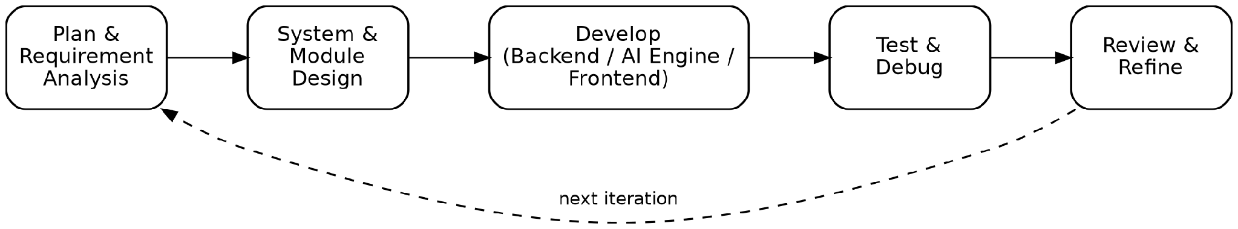
Figure 3.1: Iterative Development Methodology

3.2 Requirement Analysis

3.2.1 Functional Requirements
Functional requirements are grouped by the primary actors that interact with the system.
Home Owner / Admin:
- Home and Member Management: Create a Home, invite and remove members, and assign or update member roles and permissions.
- Device Configuration: Register and configure cameras and the smart lock, and view aggregated device health.
- Security Mode Control: Set the home's security mode (NORMAL, AWAY, HIGH, SOS).
- Monitoring and Alert Handling: View the dashboard, live camera feeds, detection-event timeline, and resolve or dismiss alerts.
Household Member / Guest / Security:
- Account and Enrollment: Register and log in, and enroll a face profile through a guided multi-pose capture.
- Permission-Scoped Viewing: View the dashboard and event timeline according to assigned permissions.
- Door Unlock Request: Request a face-verified door unlock, subject to the can_unlock_door permission.
- Conversational Query: Query past surveillance events using the natural-language chat assistant.
AI Engine (automated actor):
- Ambient Detection: Continuously detect, track, and recognize people in each active camera stream.
- Event Reporting: Open, update, and close detection-event records on the backend as tracked sessions progress and end.
- Automated Enrichment: Generate a clip, thumbnail, and natural-language summary once a session closes.
- Unlock Verification: Perform a one-shot face verification capture when a door-unlock request is received.

3.2.2 Non-Functional Requirements
- Security: All backend API access requires JWT authentication for users and a shared-secret API key for the AI engine. Door-unlock and device-control actions are additionally gated by per-member permission flags.
- Performance: The smart-lock verification flow must not block on camera inference, unlock requests are dispatched asynchronously through Celery so the web response returns immediately.
- Scalability: The AI engine runs one independent camera worker per active device, so cameras can be added without redesigning the pipeline, and the backend's Clean Architecture layering keeps business logic independent of the Django ORM.
- Reliability: A stale-session sweep on the backend closes any detection event that the AI engine failed to explicitly close, preventing sessions from being left open indefinitely.
- Privacy: Face matching is scoped strictly per home, so a face enrolled in one household is never treated as authorized in a different household.
- Usability: The dashboard consolidates security mode, device status, live preview, and recent activity into a single page load, and the chat assistant allows plain-language queries instead of manual log review.

3.3 Feasibility Analysis

3.3.1 Technical Feasibility
HomeGuard was implemented entirely with mature, well-documented, open-source technologies, Django and Django REST Framework for the backend, FastAPI for the AI engine, and established computer-vision libraries (OpenCV, Ultralytics YOLOv8, ByteTrack, InsightFace) for the perception pipeline. All of these have active communities and extensive documentation, which keeps implementation risk low. Communication between the Django backend and the FastAPI AI engine over a REST interface, authenticated with a shared API key, was implemented and tested successfully, confirming that the two-service architecture is technically sound. Locally hosted language models served through Ollama removed any dependency on a paid, internet-hosted inference API, which was an important constraint given the project's academic setting.

3.3.2 Operational Feasibility
The system is operationally feasible for a household setting: cameras are ordinary IP or smartphone cameras streaming over the local network, and no specialized hardware is required beyond a computer capable of running the AI engine. The web dashboard requires no client-side installation, and the role-based permission model maps naturally onto how households actually organize access, an owner, a small number of trusted members, and occasional guests without requiring users to understand the underlying architecture.

3.3.3 Economic Feasibility
Because HomeGuard is built entirely on open-source frameworks and locally hosted AI models rather than paid, metered cloud AI services, the recurring operating cost of the software layer is effectively zero beyond the cost of the computer running the AI engine and standard web hosting for the backend. This is a deliberate design choice: relying on Ollama-hosted models instead of a commercial vision-language API avoids per-request inference charges, which makes the system considerably cheaper to operate than a comparable cloud-AI-dependent product, and is well suited to a low-cost, consumer-facing home-security use case.

3.3.4 Schedule Feasibility
The project was scheduled across seven months, from January to July, and organized into sequential and overlapping phases covering planning, architecture and design, AI and video-processing setup, backend development, frontend development, AI integration, and system testing. Backend development and AI/video-processing setup were scheduled to overlap, since the two services could be developed largely independently once the REST contract between them was defined, which kept the overall schedule realistic within the available time.

Table 3.1: Project Schedule ( Gantt Chart )
Task / Phase | Jan | Feb | Mar | Apr | May | Jun | Jul
Planning
Architecture & Design
AI / Video-Processing Setup
Backend Development
Frontend Development
AI Integration
System Testing

3.4 System Architecture
HomeGuard is built as two cooperating services rather than a single monolith: a Django backend, organized using Clean Architecture principles, that owns users, homes, roles, devices, and stored events and a separate FastAPI AI engine that owns the real-time video pipeline, frame capture, human detection, tracking, and face recognition and communicates its results back to the Django backend over HTTP. The web dashboard and chat assistant are served by Django as server-rendered templates, styled with Tailwind CSS and made interactive with vanilla JavaScript. Splitting the system this way keeps the latency-sensitive video pipeline independent of the request/response backend, and lets the backend remain the single source of truth for identity, permissions, and stored history.
The architecture consists of four cooperating layers, shown in Figure 3.3: a presentation layer (web dashboard and chat assistant); a Django backend structured in four Clean Architecture layers: Interfaces, Application, Domain, and Infrastructure, a Celery-based asynchronous task layer that coordinates door-unlock verification without blocking the web request, and a FastAPI AI engine that performs the actual computer-vision inference and pushes results back to the backend.
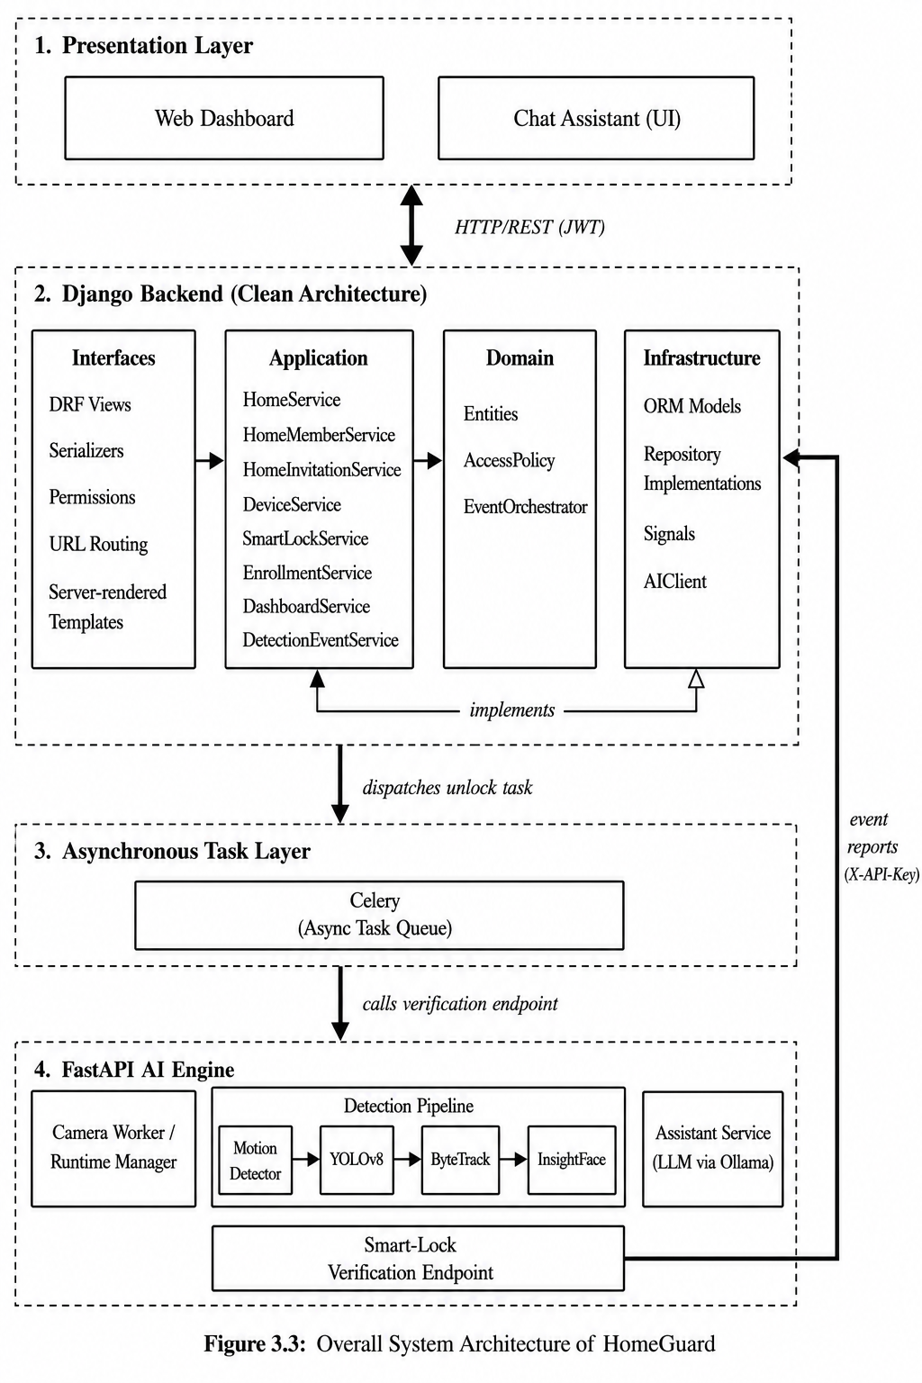
Figure 3.2: System Architecture Diagram

3.4.1 Django Backend (Clean Architecture)
- Interfaces Layer: Django REST Framework views, serializers, permission classes, and URL routing, also hosts the server-rendered web templates.
- Application Layer: Use-case services such as HomeService, HomeMemberService, HomeInvitationService, DeviceService, SmartLockService, EnrollmentService, DashboardService, and DetectionEventService, each responsible for one area of business logic.
- Domain Layer: Framework-independent entities, the AccessPolicy for permission checks, and the EventOrchestrator that governs the detection-event lifecycle.
- Infrastructure Layer: Django ORM models and repository implementations, Django signals (e.g. auto-creating DeviceSettings when a Device is created, auto-pairing a smart lock to a camera with a matching stream URL), and the AIClient used to call the AI engine.

3.4.2 FastAPI AI Engine
The AI engine runs as an independent service with its own camera worker and runtime manager. Each active camera is processed through a pipeline consisting of a motion detector, a YOLOv8-based human detector, a ByteTrack tracker that assigns a persistent track ID to each person, and an InsightFace recognition stage that compares the detected face's embedding against enrolled household members. The engine also hosts an assistant service that answers natural-language questions using a locally hosted language model, and a smart-lock verification endpoint that the Django backend calls, through Celery, when a member requests to unlock the door. Alert generation is deliberately excluded from the AI engine — it runs on a separate Windows host and is treated purely as a perception service; the decision to raise an alert is made entirely on the Django side.

3.5 Data Model Design
The core relational data model implemented in the backend is summarized in Table 3.1 and shown as an entity-relationship diagram in Figure 3.4. A door-access attempt whether granted or denied is recorded as a DetectionEvent like any other detection, rather than as a separate record type, so that all activity involving a given camera or member can be reviewed from a single, unified timeline.
Table 3.1: Core Data Model
Table | Purpose / Key Fields
User | id (PK), full_name, email, password, created_at
UserSettings | user_id (PK, FK), push_notifications, email_notifications, dark_mode, timezone
Home | id (PK), owner_id (FK), name, address, security_mode, created_at
HomeSettings | home_id (PK, FK), timeline_enabled, notify_unknown_person, ai_summary_enabled, loitering_seconds
HomeMember | id (PK), home_id (FK), user_id (FK), role, can_view_dashboard, can_control_devices, can_manage_members, can_unlock_door, receive_alerts, joined_at
HomeInvitation | id (PK), home_id (FK), invited_by (FK), email, role, permissions, status, created_at
FaceProfile | id (PK), user_id (FK), label_name, embeddings, image_url, is_verified, created_at
EnrollmentSession | id (PK), user_id (FK), invitation_id (FK), status, ai_engine, started_at, completed_at
Device | id (PK), home_id (FK), paired_camera_id (FK), name, device_type, ip_address, stream_url, location, status, last_active
DeviceSettings | device_id (PK, FK), enabled, motion_detection, human_detection, face_recognition, confidence_threshold, recording_enabled
SmartLock | id (PK), device_id (FK), last_unlocked_by (FK), status, last_unlocked_at, current_verification_id, last_access_result
DetectionEvent | id (PK), home_id (FK), device_id (FK), matched_member_id (FK), matched_face_id (FK), track_id, event_type, person_type, confidence_score, status, pipeline_stage, timestamp
Alert | id (PK), home_id (FK), event_id (FK), resolved_by (FK), severity, reason, status, created_at
AccessLog | id (PK), user_id (FK), device_id (FK), action, result, event_type, confidence_score, created_at

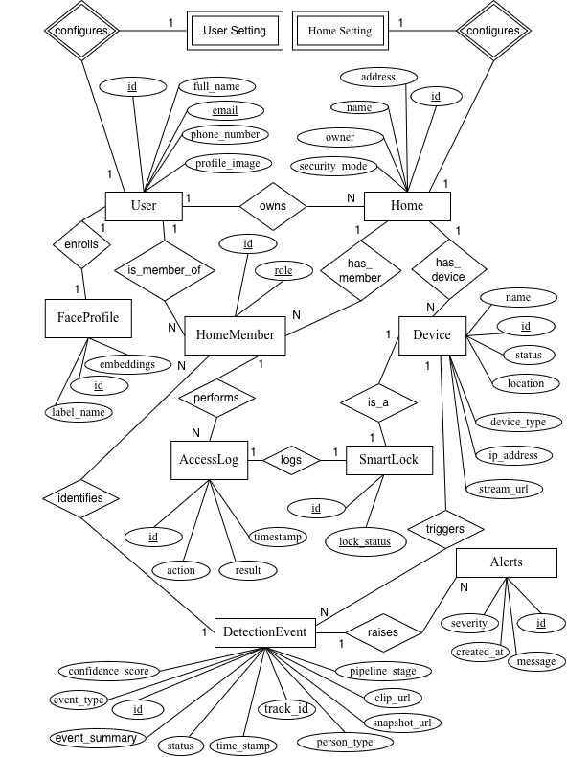

Figure 3.3: Entity-Relationship Diagram

3.6 Role-Based Access Control
Rather than a single access level for every user, each HomeMember record carries a role together with four independent boolean permissions. Default permissions per role are summarized in Table 3.2; an OWNER or ADMIN may additionally override individual permissions for a member when assigning or updating their role.
Table 3.2: Role-Based Permission Matrix (default permissions per role)
Role | Control Devices | Manage Members | Unlock Door | Receive Alerts
OWNER | Yes | Yes | Yes | Yes
ADMIN | Yes | Yes | Yes | Yes
MEMBER | No | Yes | Yes | Yes
GUEST | No | No | Yes | No
SECURITY | No | No | No | Yes

3.7 Use Cases
Figure 3.5 summarizes the primary actors and use cases. The Owner/Admin actor has the widest set of capabilities, including inviting members and configuring devices; regular Members and Guests can view the dashboard, unlock the door if permitted, and query the assistant; the AI Engine acts as an automated actor responsible for detection, recognition, and event reporting.
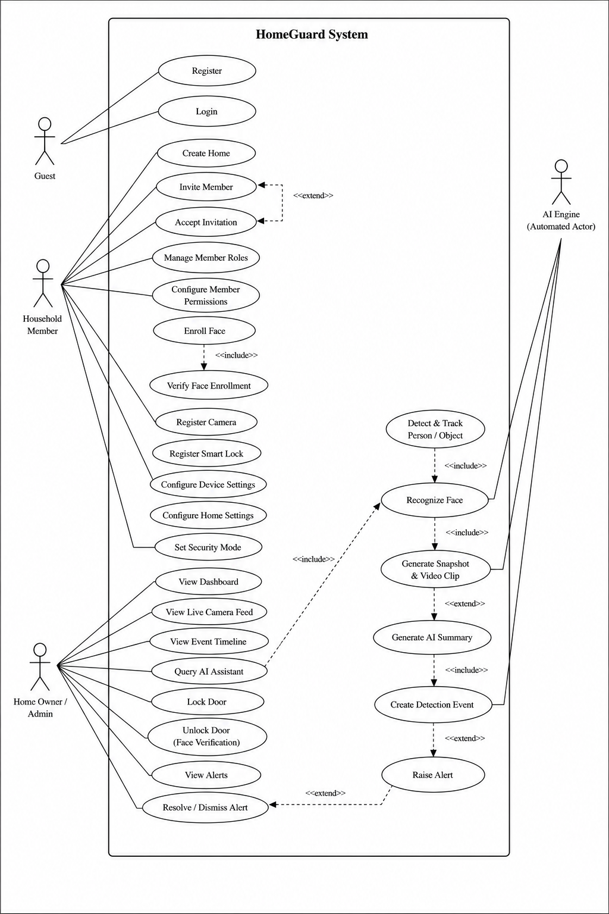
Figure 3.4: Use Case Diagram

3.8 AI Detection and Smart-Lock Access Flow
HomeGuard uses two independent workflows instead of a single detect-and-unlock pipeline. A key design aspect of HomeGuard is that it uses two independent workflows instead of a single detect-and-unlock pipeline. The first is a continuous surveillance flow that performs detection, tracking, recognition, session logging, and AI-generated event summaries. It only records surveillance events, while the Django backend independently determines whether an alert should be generated based on person.

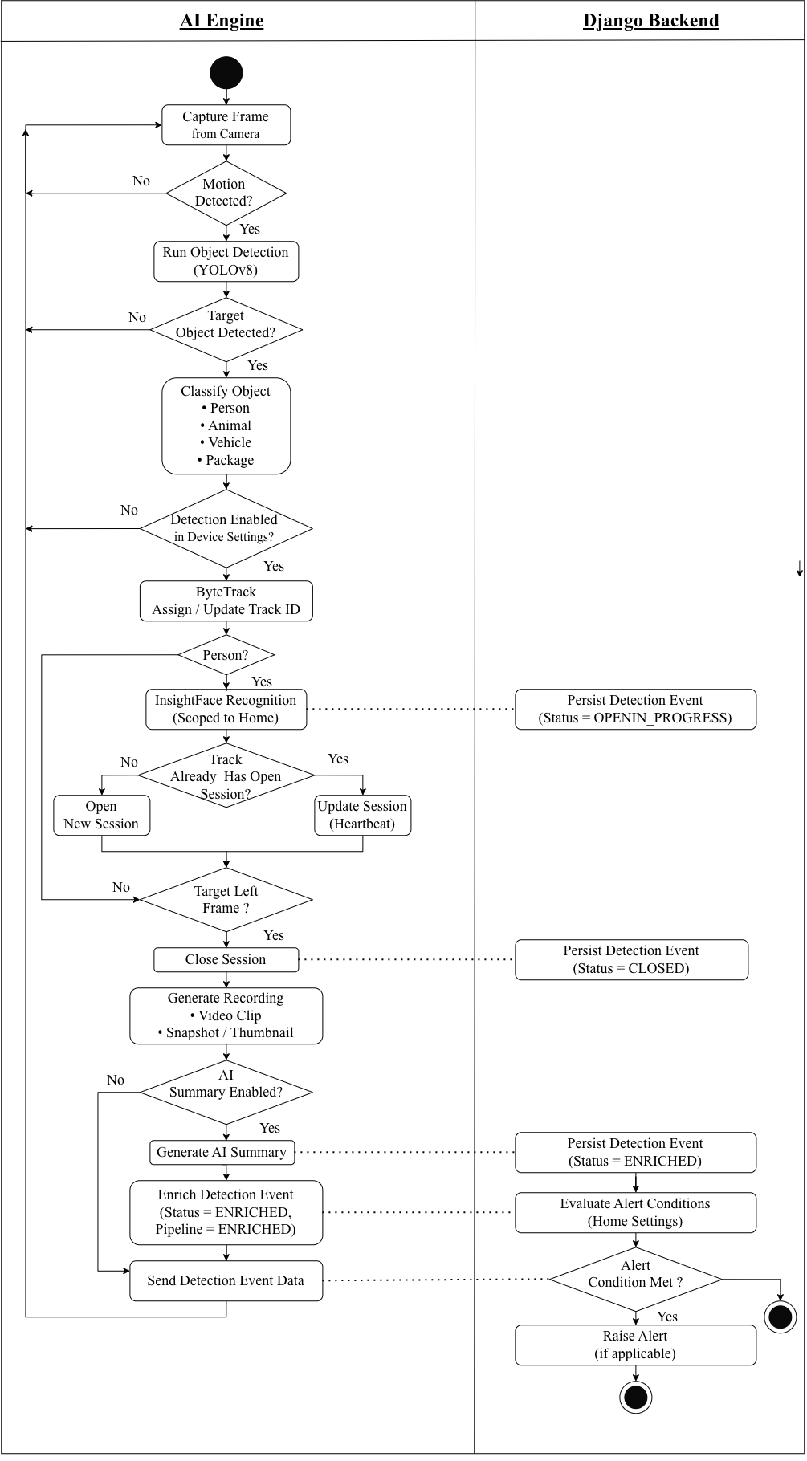
Figure 3.5: Activity Diagram ( AI Detection and Recognition Pipeline )
Flow B, shown as a sequence diagram in Figure 3.7, is the smart-lock verification flow, and it is triggered only by an explicit button press, not by anything the ambient pipeline observes. Django checks the acting member's can_unlock_door permission, marks the lock VERIFYING, and dispatches a Celery task. The AI engine then performs a separate, one-shot capture of up to fifteen frames from the door's paired camera and compares the best face found against the home's enrolled members; this capture and match are independent of the ByteTrack tracks or sessions Flow A may already be maintaining for the same camera. Django applies the result: on a match, the lock is marked UNLOCKED and automatically reverts to LOCKED after a short interval unless superseded by a newer request or a manual lock; otherwise the lock remains LOCKED and an ACCESS_DENIED event is logged. A consequence of this separation is that a recognized member simply walking into view of a camera does not, by itself, unlock anything unlocking always requires the explicit button-triggered verification in Flow B.
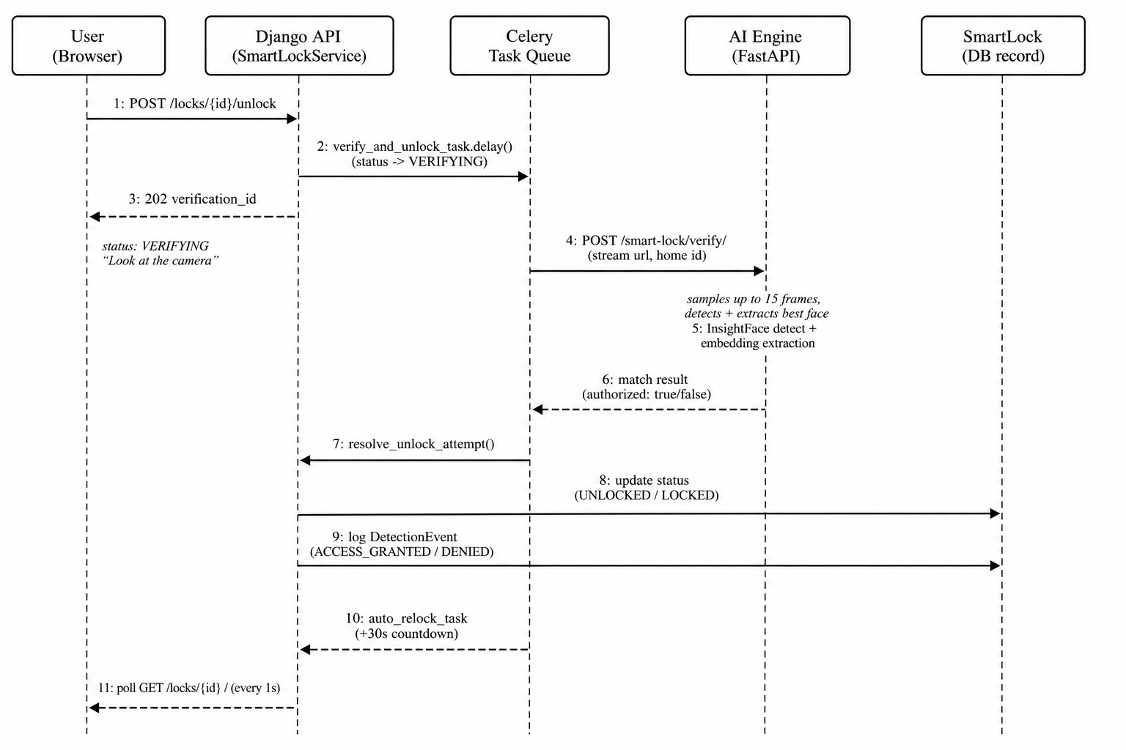
Figure 3.7: Sequence Diagram ( Face-Verified Door Unlock )

3.9 Security and Privacy Measures
- JWT and API-Key Authentication: Authentication is handled with JWT access/refresh tokens; the AI engine, which has no user account, authenticates to the backend with a separate shared-secret API key.
- Per-User Face Storage: Face embeddings are stored per user rather than per home, and enrollment requires a verified face profile (IsFaceEnrolled permission) before certain actions are allowed.
- Per-Home Matching Scope: Face matching is scoped strictly to the household associated with the camera in question, preventing a face enrolled in one home from being recognized as authorized in a different, unrelated home.
- Safe Password Reset: Password reset flows avoid confirming whether a given email is registered, and reset tokens are single-use and time-limited.
- Permission-Gated Actions: Door-unlock and device-control actions are gated by the acting user's HomeMember permissions rather than by authentication alone, so a logged-in member without can_unlock_door cannot open the door.

Chapter 4: Implementation

4.1 Technology Stack
Table 4.1 summarizes the primary technologies used across the backend, AI engine, and frontend.
Table 4.1: Technology Stack
Category | Technology
Backend Framework | Django, Django REST Framework
AI Engine Framework | FastAPI (Python)
Object Detection | YOLOv8 (Ultralytics)
Multi-Object Tracking | ByteTrack
Face Detection & Recognition | InsightFace
Motion Detection | OpenCV (MOG2 background subtraction)
Local Language Models | Ollama — Qwen2.5-VL (event summarization), gemma3:4b (chat assistant)
Asynchronous Tasks | Celery
Database | PostgreSQL (production), SQLite (local development)
Authentication | JSON Web Tokens (djangorestframework-simplejwt)
Frontend | Django Templates, HTML, Tailwind CSS, vanilla JavaScript
Media Storage | Cloudinary (clips and thumbnails)
Development Environment | Visual Studio Code, Git

4.2 Backend Module Implementation

4.2.1 Home and Membership Management
HomeService creates a Home and simultaneously creates the owner's HomeMember record with full permissions. HomeMemberService restricts role and permission updates to members with can_manage_members, and permission overrides supplied by the caller are filtered to the four known keys before being applied, so an update request cannot inject arbitrary fields. Invitations are handled by HomeInvitationService, which prevents duplicate pending invitations, self-invitation, and inviting a user who already belongs to the home.

4.2.2 Device Registration and Health
DeviceService registers cameras and smart locks under a Home, guarded by can_control_devices, and automatically creates a corresponding SmartLock row, defaulting to LOCKED, when a smart-lock-type device is registered. A Django signal separately watches for a smart lock and a camera sharing the same stream_url within a home and auto-pairs them, so the smart-lock verification flow knows which camera to inspect without requiring manual configuration. DeviceHealthService merges the database's last-known device status with live status latency, FPS, and whether the AI engine is actively processing frames — reported by the AI engine.

4.2.3 Face Enrollment
EnrollmentService reuses a pending enrollment session if one already exists for a user, preventing duplicate sessions from repeated scan attempts. Enrollment guides the user through five head poses — center, left, right, up, and down — capturing multiple frames per pose and retaining only the highest-quality embeddings. On completion, a single FaceProfile per user is created or updated with the submitted embeddings and marked verified; the face profile is attached to the user rather than to a specific home, so it can be reused if the user belongs to more than one home.

4.2.4 Detection Event Lifecycle
The system maintains two related but distinct notions of a session, one on each side of the network boundary. On the AI-engine side, an in-memory session manager, one instance per camera worker, keeps exactly one session object per active ByteTrack track ID, created the instant a track is first assigned and updated every frame as recognition results improve; this is purely local bookkeeping and is never itself persisted. On the Django side, DetectionEventService, backed by an EventOrchestrator, owns the persisted record: the AI engine calls Django's open-event endpoint the first time a track's identity resolves past unseen, calls a progress endpoint on a five-second heartbeat while the track remains active, and calls a close endpoint once the track is lost, after which an enrichment step attaches a clip URL, thumbnail, and summary. A periodic sweep on the Django side closes any stored session that was never explicitly closed by the AI engine, guarding against a crashed or disconnected camera worker leaving a session open indefinitely.

4.2.5 Smart-Lock Verification Flow
Unlocking is deliberately asynchronous, so the web request never blocks on camera inference, and deliberately independent of the ambient pipeline described in Section 3.8, so a slow or backlogged detection pipeline cannot delay a door-open request. start_unlock_attempt checks the caller's can_unlock_door permission, marks the lock VERIFYING with a fresh verification ID, and hands off to a Celery task. That task calls a dedicated AI-engine endpoint which performs its own short capture, up to fifteen frames, from the door's paired camera, keeps the highest-confidence face found, and matches its embedding against the requesting home's enrolled members only. resolve_unlock_attempt applies the result on the Django side: on success, the lock is marked UNLOCKED, the acting member is recorded, an ACCESS_GRANTED event is logged, and an auto-relock task is scheduled; on failure, the lock remains LOCKED and an ACCESS_DENIED event is logged. The auto-relock task and manual lock both check the verification ID before acting, so a superseded or already-resolved attempt cannot re-lock a door opened by a newer request. This objective-two behavior recognition feeding a role-checked, independently verified unlock decision rather than an automatic one is exercised directly by test cases F-06, S-01, SEC-02, N-01, and N-02 in Chapter 5.

4.2.6 Per-Home Scoping of Face Matching
Both recognition paths the ambient pipeline's recognition stage and the smart-lock verification service match a detected face only against the embeddings enrolled for that specific home, through a known-faces cache keyed by home ID and refreshed per home. This was a deliberate correction made during development: matching against a single global list of every enrolled face across every home would have let a person enrolled in one household be recognized as authorized in a different, unrelated household. Scoping the match to the home tied to the camera in question closes that gap, and is verified directly by test case SEC-04 in Chapter 5.

4.3 Web Dashboard
The dashboard is served as a Django template and populated client-side through authenticated fetch calls to the REST API. DashboardService assembles a single payload per request home information, current security mode, a summary message driven by recent alert and unknown-detection counts, aggregate statistics, a live preview of up to four cameras, and the most recent events so the page renders in one round trip. The front-door camera and smart lock are combined into a single hero card whose lock icon reflects LOCKED, VERIFYING, and UNLOCKED states, and the page polls the lock's status while a verification is in progress so the UI updates as soon as the AI engine responds. This satisfies the secure, user-friendly access to surveillance data called for in Objective 1.

4.4 Chat Assistant and Automated Event Summarization
Two separate locally hosted language models are used for two different purposes, both served through Ollama, directly fulfilling the natural-language access requirement of Objective 1. First, when a tracked person's session closes, an enrichment step selects the sharpest available frame from the event's clip falling back to the best face crop, then a saved snapshot, if no usable clip exists and sends it to a vision-language model (Qwen2.5-VL) to generate a one-sentence, factual description of the event; if that model is unavailable or too slow, a rule-based summary describing who was seen, for how long, and where is generated instead, so an event is never left without a summary. Second, the assistant view sends the user's natural-language question, together with the active home's ID, to Django, which forwards it to the AI engine's assistant endpoint; there, a text-only model (gemma3:4b, chosen for its lower latency compared to the vision model) answers strictly from the home's recent events fetched from Django, and returns a concise, conversational answer rather than a formal report. Together, these two uses remove the need to review raw footage event by event, and give conversational access to that summarized history.

Chapter 5: Testing and Results
Testing was organized into six categories: functional, integration, system, security, negative, and performance, to cover both individual module correctness and end-to-end system behavior. Each test case below records the scenario exercised, the expected result, the actual observed result, and a pass/fail status; no test listed here was left unexecuted.

5.1 Functional Testing
Functional tests verify that individual modules behave correctly in isolation, covering home and role management, device registration, face enrollment, detection-event handling, the smart-lock decision itself, and the chat assistant.
Table 5.1: Functional Test Cases and Results
ID | Module | Test Scenario | Expected Result | Actual Result | Status
F-01 | Home Management | Create a Home as a new user. | User becomes OWNER with full default permissions. | As expected | Pass
F-02 | RBAC | Member without can_manage_members attempts to change another member's role. | Request rejected (403 Forbidden). | As expected | Pass
F-03 | Device Registration | Register a smart-lock-type device under a Home. | SmartLock row auto-created, defaulting to LOCKED. | As expected | Pass
F-04 | Face Enrollment | Complete the guided 5-pose capture (CENTER/LEFT/RIGHT/UP/DOWN). | Single FaceProfile created/updated and marked verified. | As expected | Pass
F-05 | Detection Event | AI engine reports a resolved track. | DetectionEvent opened, then progressed, then closed correctly. | As expected | Pass
F-06 | Smart Lock | Authorized member requests unlock; captured face matches. | Lock set to UNLOCKED; ACCESS_GRANTED event logged. | As expected | Pass
F-07 | Chat Assistant | User asks a natural-language question about recent activity. | Answer generated strictly from that home's own recent events. | As expected | Pass

5.2 Integration Testing
Integration tests verify that the Django backend, the FastAPI AI engine, and Celery correctly exchange data and coordinate state across their service boundary.
Table 5.2: Integration Test Cases and Results
ID | Module | Test Scenario | Expected Result | Actual Result | Status
I-01 | AI Engine ↔ Django | AI engine calls the open/progress/close event endpoints. | Django persists the event and returns it with an id. | As expected | Pass
I-02 | Celery ↔ Smart Lock | Unlock verification task completes and resolves the attempt. | Lock status and last_unlocked_by updated consistently. | As expected | Pass
I-03 | Django Signals | A smart lock and a camera are registered with the same stream_url. | Signal auto-pairs the two devices via paired_camera. | As expected | Pass
I-04 | RuntimeManager ↔ Django | AI engine syncs active cameras and settings from Django. | New, changed, or removed cameras reconciled without restarting the engine. | As expected | Pass

5.3 System (End-to-End) Testing
System tests exercise a complete user-facing workflow from trigger to final observable state, rather than a single module.
Table 5.3: System Test Cases and Results
ID | Module | Test Scenario | Expected Result | Actual Result | Status
S-01 | Door Unlock (E2E) | Button press through to lock resolution. | VERIFYING → AI capture → grant/deny → auto-relock completes end-to-end. | Confirmed via live API logs | Pass
S-02 | Detection Lifecycle (E2E) | A person enters and then leaves camera view. | Clip, thumbnail, and AI summary attached to the closed event. | As expected | Pass
S-03 | Dashboard (E2E) | Load the dashboard for a home. | Security mode, stats, live preview, and recent events render in one request. | As expected | Pass

5.4 Security Testing
Security tests confirm that authentication, permission checks, and the per-home face-matching boundary are correctly enforced.
Table 5.4: Security Test Cases and Results
ID | Module | Test Scenario | Expected Result | Actual Result | Status
SEC-01 | Authentication | Request a protected endpoint with no or an expired JWT. | 401 Unauthorized returned. | As expected | Pass
SEC-02 | RBAC | Member without can_unlock_door requests an unlock. | 403 Forbidden; lock state unchanged. | As expected | Pass
SEC-03 | AI Engine Auth | Call an AI-engine endpoint without a valid X-API-Key. | Request rejected by the IsAIEngine permission. | As expected | Pass
SEC-04 | Face Isolation | A face enrolled in Home A is tested against Home B's camera. | Not matched as known; treated as unknown. | Confirmed (corrected during development) | Pass
SEC-05 | Password Reset | Request a password reset for a non-existent email. | Generic success message; no account-existence disclosure. | As expected | Pass

5.5 Negative Testing
Negative tests confirm that the system fails safely remaining locked, rejecting invalid requests when inputs or conditions are not as expected.
Table 5.5: Negative Test Cases and Results
ID | Module | Test Scenario | Expected Result | Actual Result | Status
N-01 | Smart Lock | Unlock attempt where no face is found in any sampled frame. | reason: no_face; door remains LOCKED. | As expected | Pass
N-02 | Smart Lock | Unlock attempt where only a low-confidence face is found. | reason: low_quality; door remains LOCKED. | As expected | Pass
N-03 | Invitation | Send a second pending invitation to the same email. | Rejected as a duplicate pending invitation. | As expected | Pass
N-04 | Invitation | Owner attempts to invite themselves. | Rejected with a validation error. | As expected | Pass
N-05 | RBAC | Attempt to assign the OWNER role through the role-update endpoint. | Rejected; OWNER cannot be assigned this way. | As expected | Pass

5.6 Discussion
Testing confirms that the role-based access model and enrollment flow behave as designed: permission checks correctly restrict role and member management to authorized users, and enrollment sessions are correctly de-duplicated and converted into a verified face profile. The AI detection pipeline correctly extracts and matches face embeddings, and critically, correctly refuses to match a face across homes it was not enrolled in, confirming that the per-home scoping fix described in Section 4.2.6 closes the cross-home recognition gap it was designed to close.
The smart-lock verification flow was exercised end-to-end, including the asynchronous unlock request, face-verification capture, access-granted and access-denied outcomes, and automatic re-locking after the configured interval, live API request logs captured during testing confirm the expected sequence of a VERIFYING status followed by client polling and a final LOCKED or UNLOCKED resolution.
Chapter 6: Conclusion and Future Work

6.1 Conclusion
This project set out to achieve two specific objectives: an AI-based surveillance system offering secure, conversational access to surveillance data, and a role-based smart door access system using face recognition. Both objectives were met by the completed system, as demonstrated throughout this report:
- Intelligent, Identity-Aware Surveillance: A YOLOv8 and ByteTrack perception pipeline, combined with InsightFace recognition scoped per household, replaces passive motion-triggered recording with structured, identity-aware detection events (Sections 3.8, 4.2.4).
- Secure Role-Based Access Control: Each household member's role and independent permission flags govern device control, member management, door-unlock rights, and alert delivery, verified directly by the RBAC and security test cases in Chapter 5.
- Face-Verified Smart-Lock Authentication: Door access is granted only through an explicit, independently verified unlock request rather than an automatic reaction to recognition, confirmed end-to-end by test cases F-06 and S-01.
- AI-Assisted Event Summarization: A locally hosted vision-language model automatically generates a natural-language description of each closed detection event, with a rule-based fallback ensuring no event is left undescribed.
- Conversational Querying of Surveillance History: A locally hosted language model answers natural-language questions about a home's own recent events, fulfilling the accessible-query requirement.
The resulting system separates concerns cleanly, a Django backend, structured with Clean Architecture, owns identity, roles, and permissions, a FastAPI AI engine owns the real-time computer-vision pipeline and the two communicate over a well-defined REST boundary rather than being tightly coupled. Deliberately separating the always-on detection pipeline from the explicitly triggered smart-lock verification flow ensures that a recognized face alone never unlocks a door, unlocking always requires a distinct, user-initiated request, independently verified. On this basis, both project objectives are considered successfully achieved, and HomeGuard demonstrates a practical, low-cost, identity-aware alternative to passive CCTV monitoring for residential use.

6.2 Future Work
- Push and Email Notifications: Implement real-time push or email notifications for unknown-person and intruder events, building on the existing Alert model.
- Vector-Based Event Search: Extend the assistant service with a vector database for more robust natural-language search over historical events.
- Legacy Code Cleanup: Remove or refactor the legacy synchronous event-processing path once the session-based orchestrator is confirmed as the sole event-logging path in production.
- Accuracy Evaluation Under Varied Conditions: Evaluate detection and recognition accuracy under varied lighting and camera placement, and consider fine-tuning or additional models if needed.
- Physical Smart-Lock Integration: Integrate the smart-lock simulation with a physical locking mechanism for a full hardware deployment.
- Edge AI Deployment: Explore running lightweight versions of the detection and recognition models directly on camera-adjacent edge devices to reduce network dependency and latency.

References
[1] Muhammad, R., Sagara, M. S. A., Teluma, Y. M., & Wicaksana, F. A. (2025). AI as modern technology for home security systems: A systematic literature review. Engineering Proceedings, 107(1), 35.
[2] Oguine, K. J., et al. (2022). YOLO v3: Visual and real-time object detection model for smart surveillance systems. arXiv.
[3] Rahim, A., et al. (2023). Enhancing smart home security with face recognition using deep learning. International Journal for Research in Applied Science and Engineering Technology (IJRASET).
[4] Mrak, V. (2023). Face recognition methods in video surveillance systems using machine learning. In Proceedings of ICTEE.
[5] Zhang, Y., Sun, P., Jiang, Y., et al. (2022). ByteTrack: Multi-object tracking by associating every detection box. In Proceedings of the European Conference on Computer Vision (ECCV).
[6] Xu, J. (2021). A deep learning approach to building an intelligent video surveillance system. Multimedia Tools and Applications.
[7] Jocher, G., Chaurasia, A., & Qiu, J. (2023). Ultralytics YOLOv8 (Version 8.0.0) [Software]. Ultralytics.
[8] Deng, J., Guo, J., Xue, N., & Zafeiriou, S. (2019). ArcFace: Additive angular margin loss for deep face recognition. In Proceedings of the IEEE/CVF Conference on Computer Vision and Pattern Recognition (CVPR). (InsightFace reference model.)
[9] Bradski, G. (2000). The OpenCV Library. Dr. Dobb's Journal of Software Tools.
[10] Ferraiolo, D. F., Sandhu, R., Gavrila, S., Kuhn, D. R., & Chandramouli, R. (2001). Proposed NIST standard for role-based access control. ACM Transactions on Information and System Security, 4(3), 224–274.
[11] Martin, R. C. (2017). Clean Architecture: A Craftsman's Guide to Software Structure and Design. Prentice Hall.
[12] Django Software Foundation. (2025). Django REST Framework Documentation. Retrieved from https://www.django-rest-framework.org/
[13] Ramírez, S. (2025). FastAPI Documentation. Retrieved from https://fastapi.tiangolo.com/
[14] Celery Project. (2025). Celery: Distributed Task Queue Documentation. Retrieved from https://docs.celeryq.dev/
[15] Ollama Inc. (2025). Ollama Documentation. Retrieved from https://ollama.com/

Appendices

Appendix A: System User Interface Screenshots

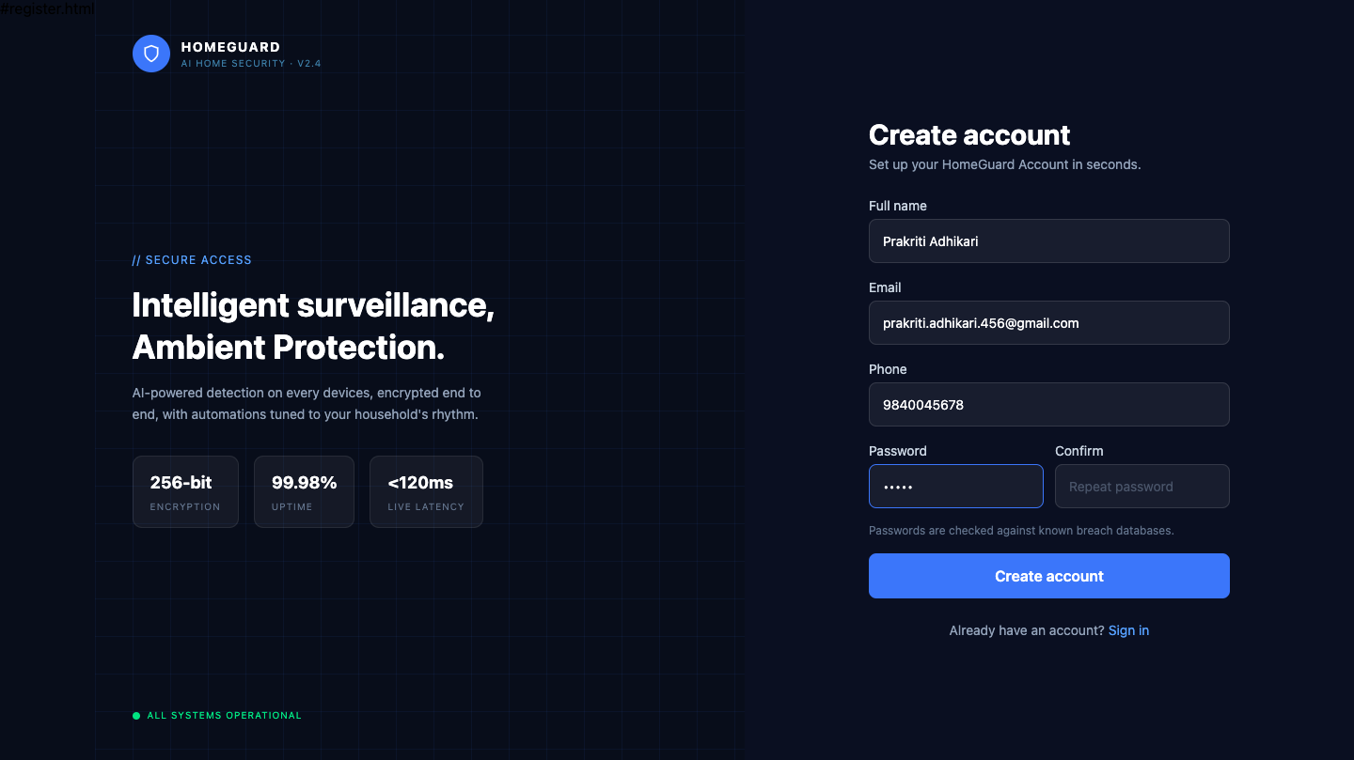

Figure A.1: HomeGuard Account Registration View

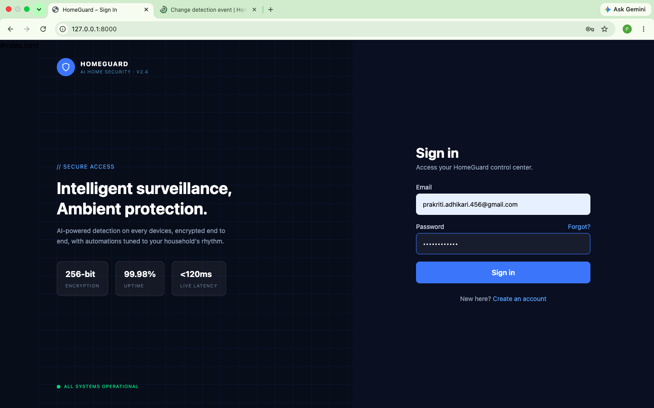

Figure A.2: HomeGuard Authentication View

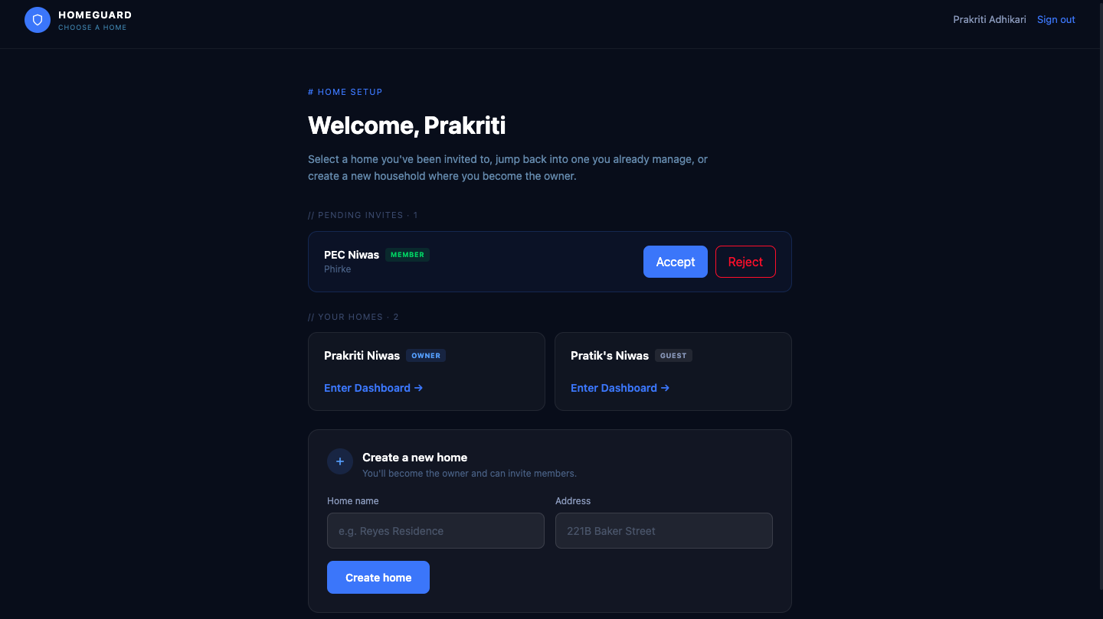

Figure A.3: Household Selection & Setup Panel

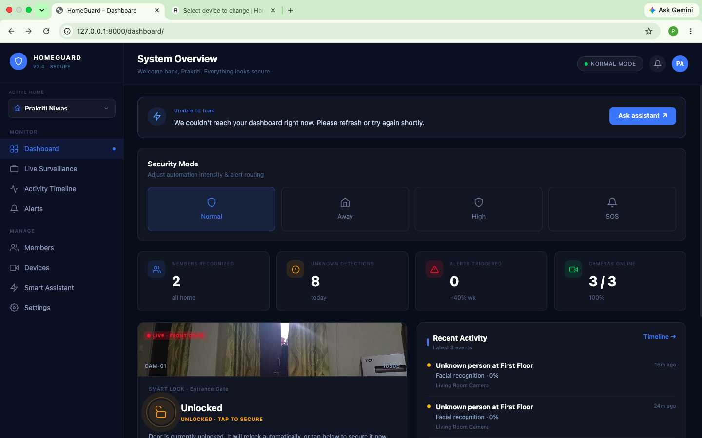

Figure A.4a: Dashboard Header, AI Assistant & Security Modes
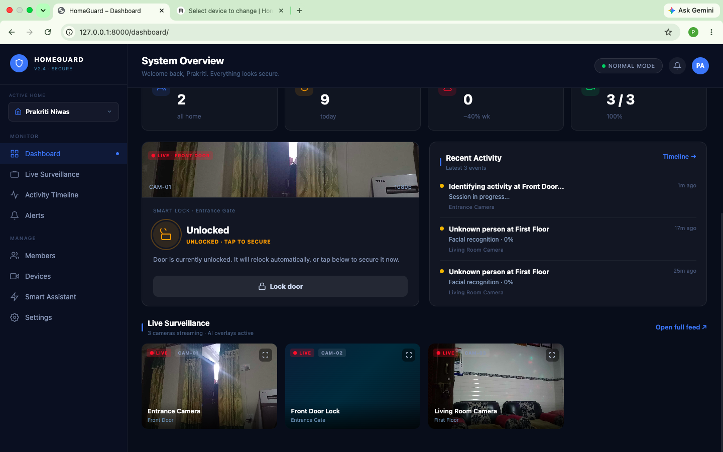

Figure A.4b: Dashboard Lower Feed & Live Surveillance

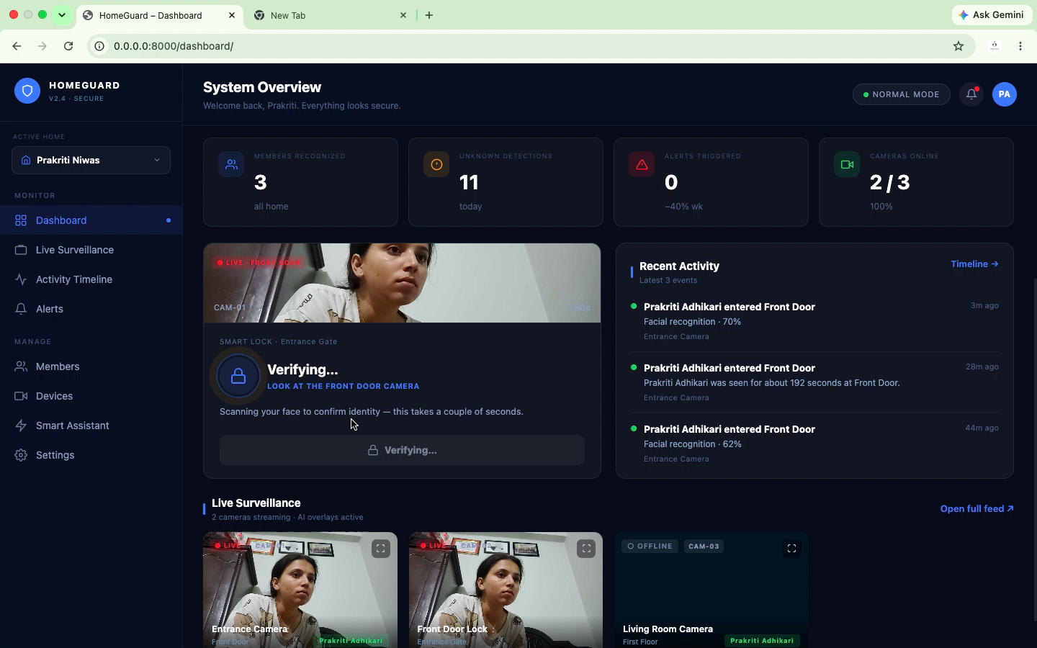

Figure A.4c: Dashboard Real-Time Identity Scanning State for Smart Lock
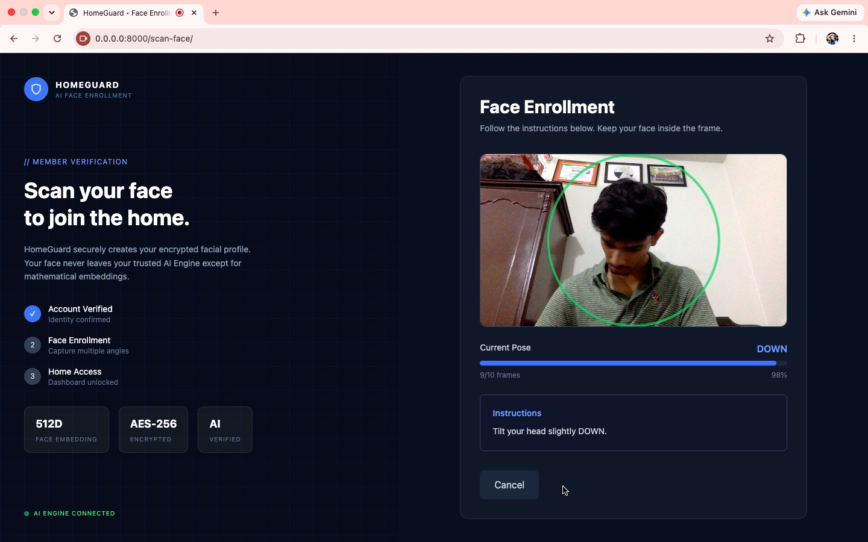

Figure A.5: User Face Enrollment Screen

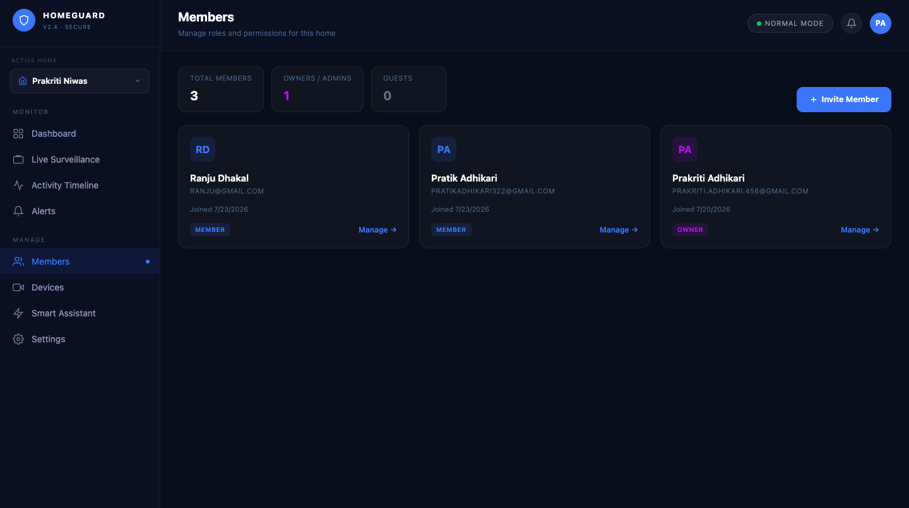

Figure A.6: HomeGuard Household Members Directory View
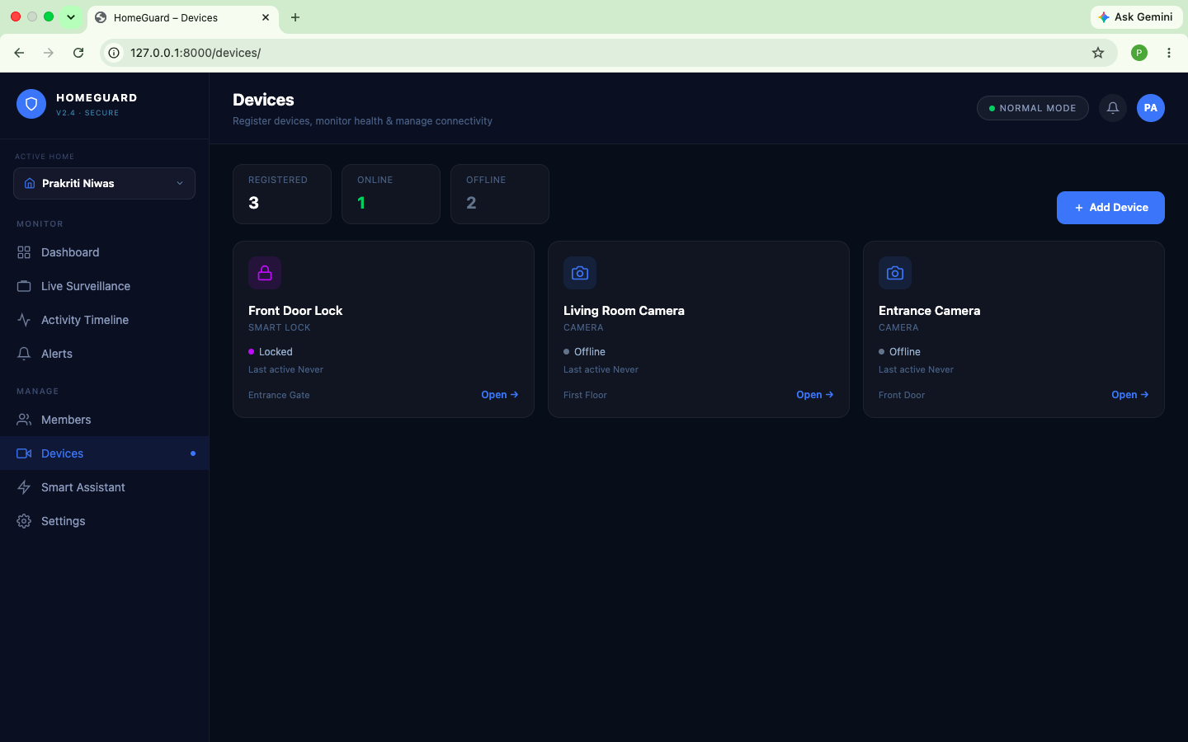

Figure A.7: HomeGuard Device Directory View
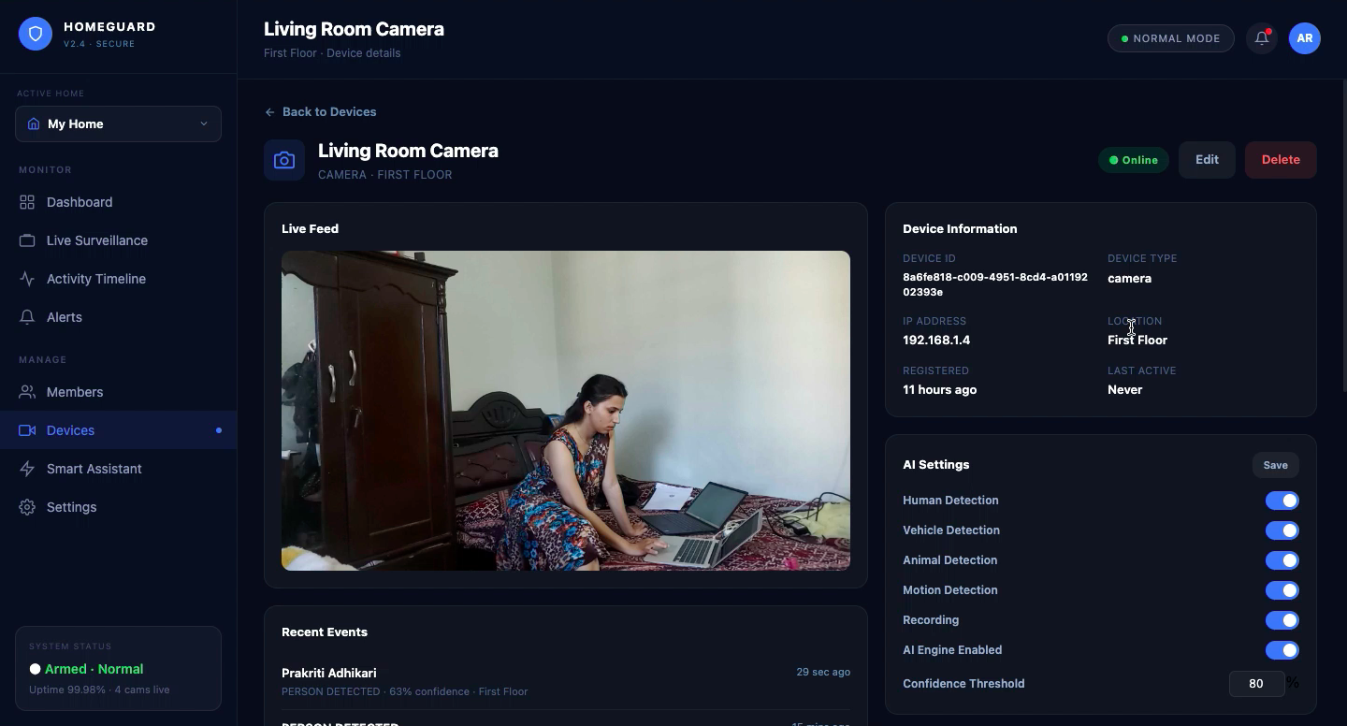

Figure A.8: Device Detail View
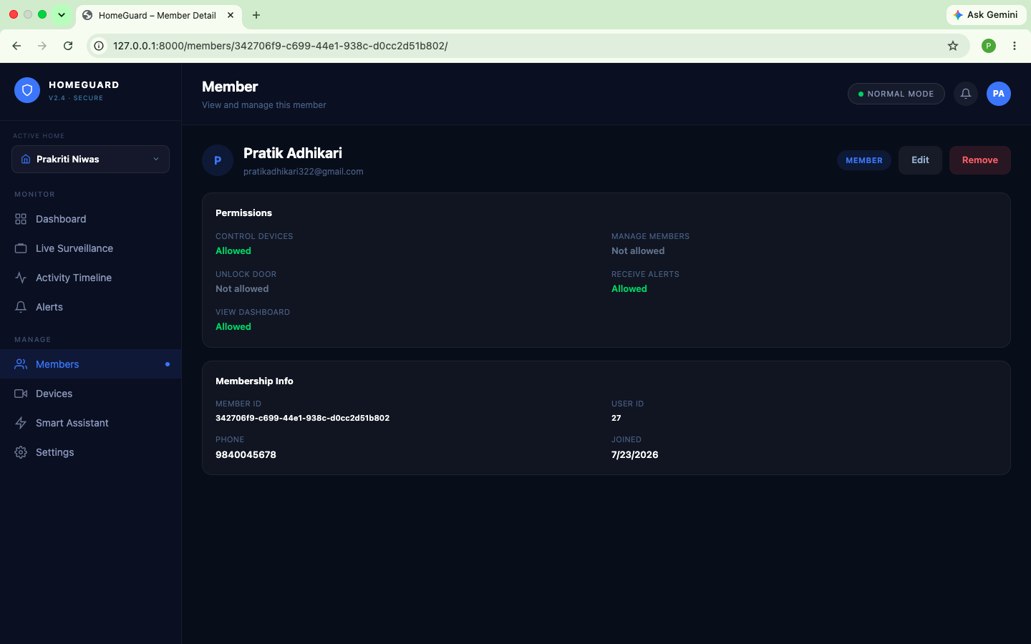

Figure A.9: Member Profile & Access Management Detail
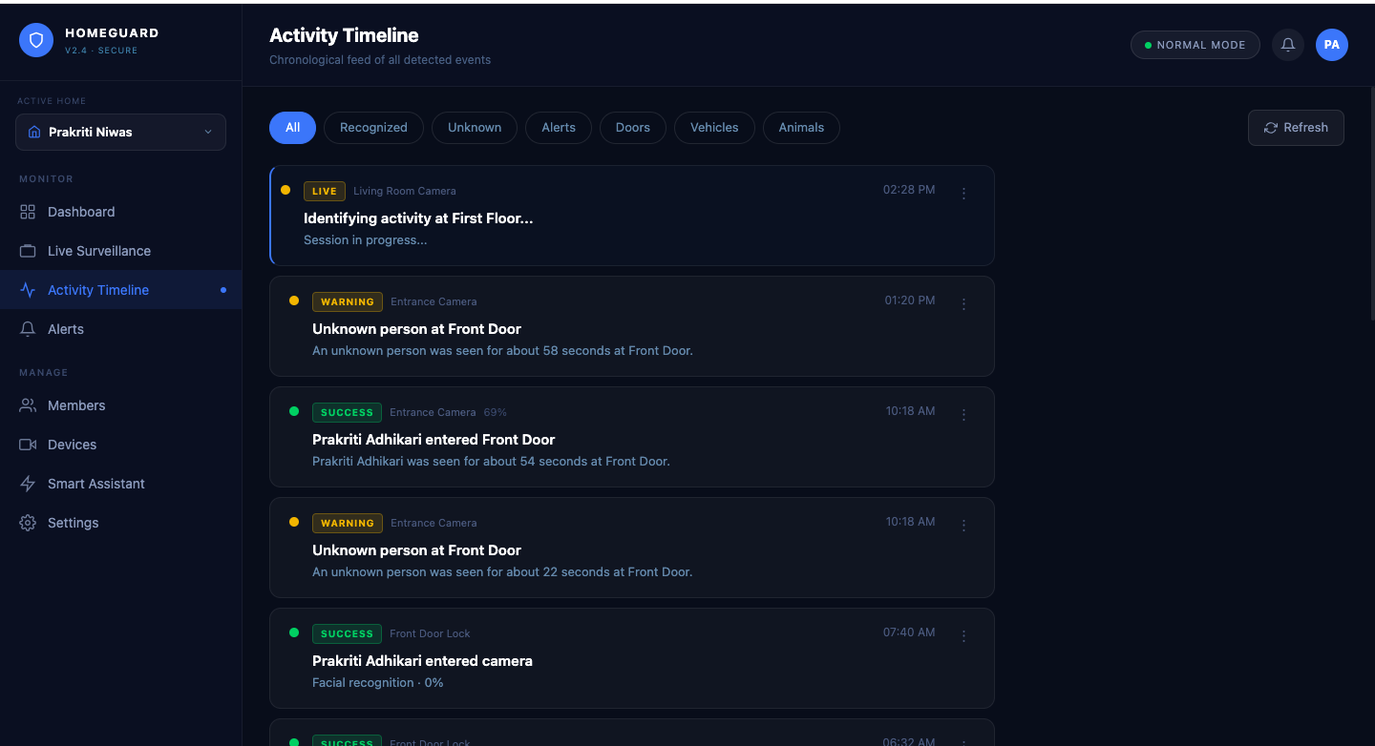

Figure A.10: HomeGuard Activity Timeline Feed View
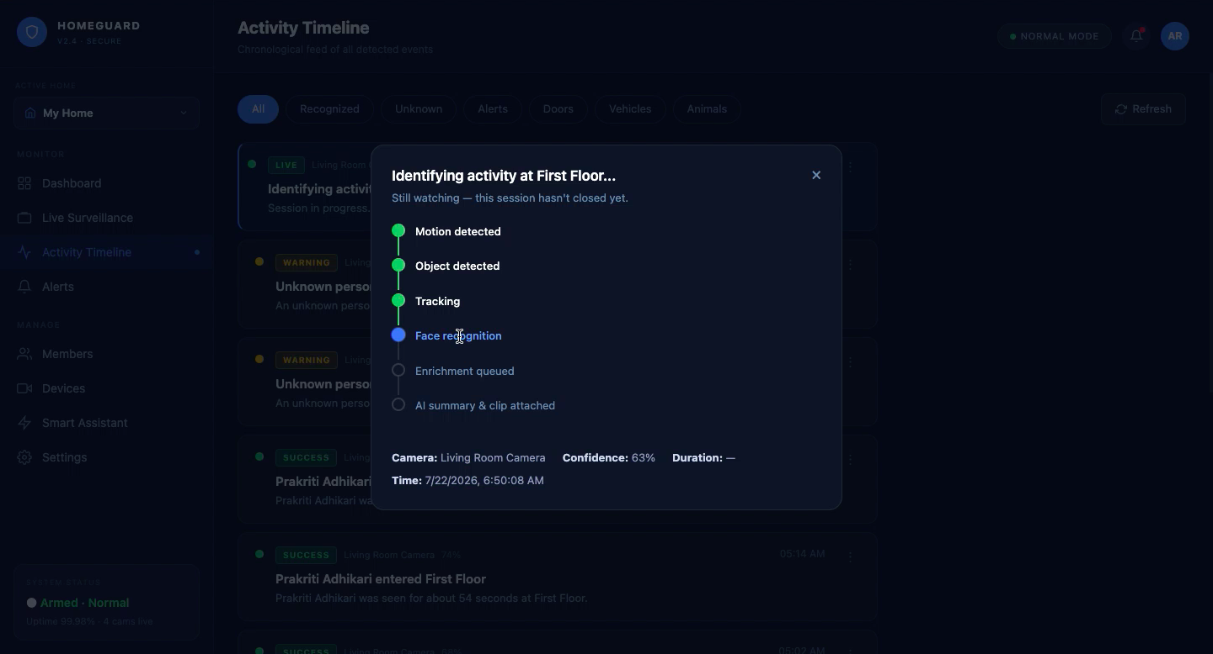

Figure A.11: HomeGuard Live Event Processing & Analysis Modal
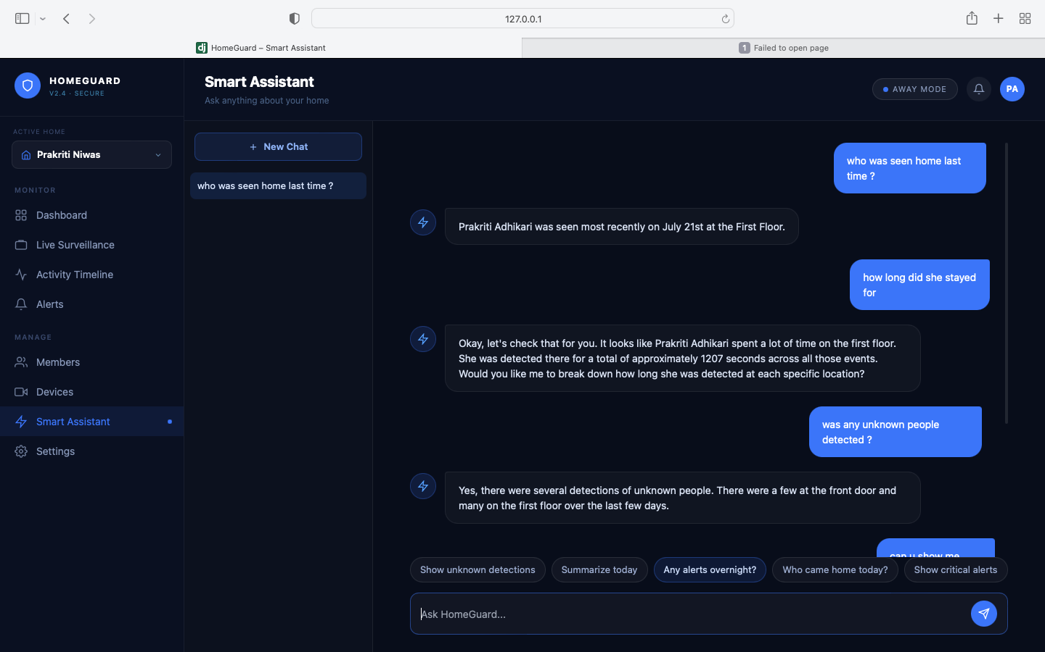

Figure A.12: HomeGuard Smart Assistant Chat Interface

Appendix B: Django Admin Panel Screenshots
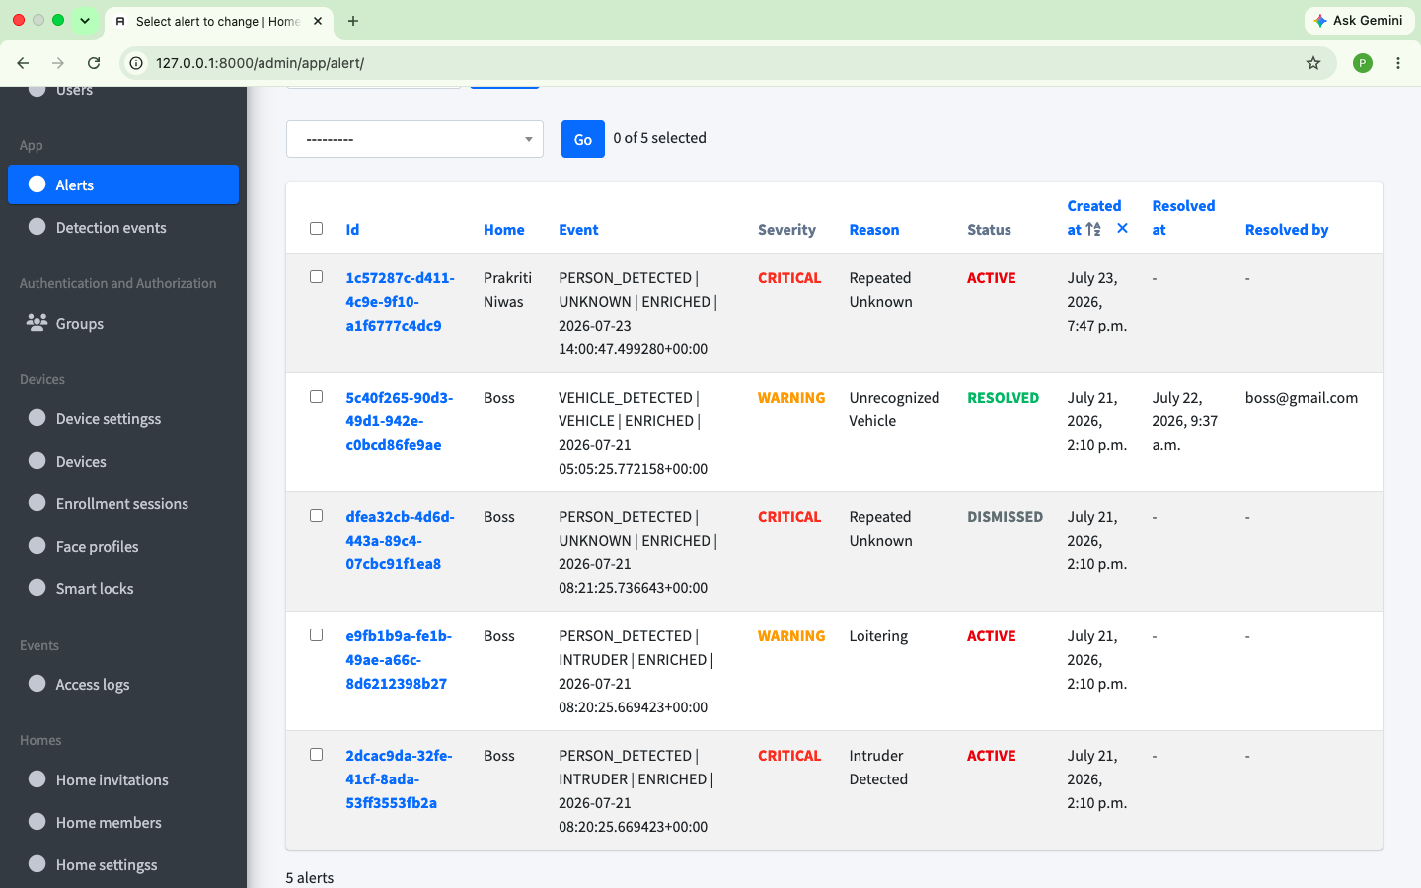

Figure B.1: Django Administrative Portal: Security Alert Management Table

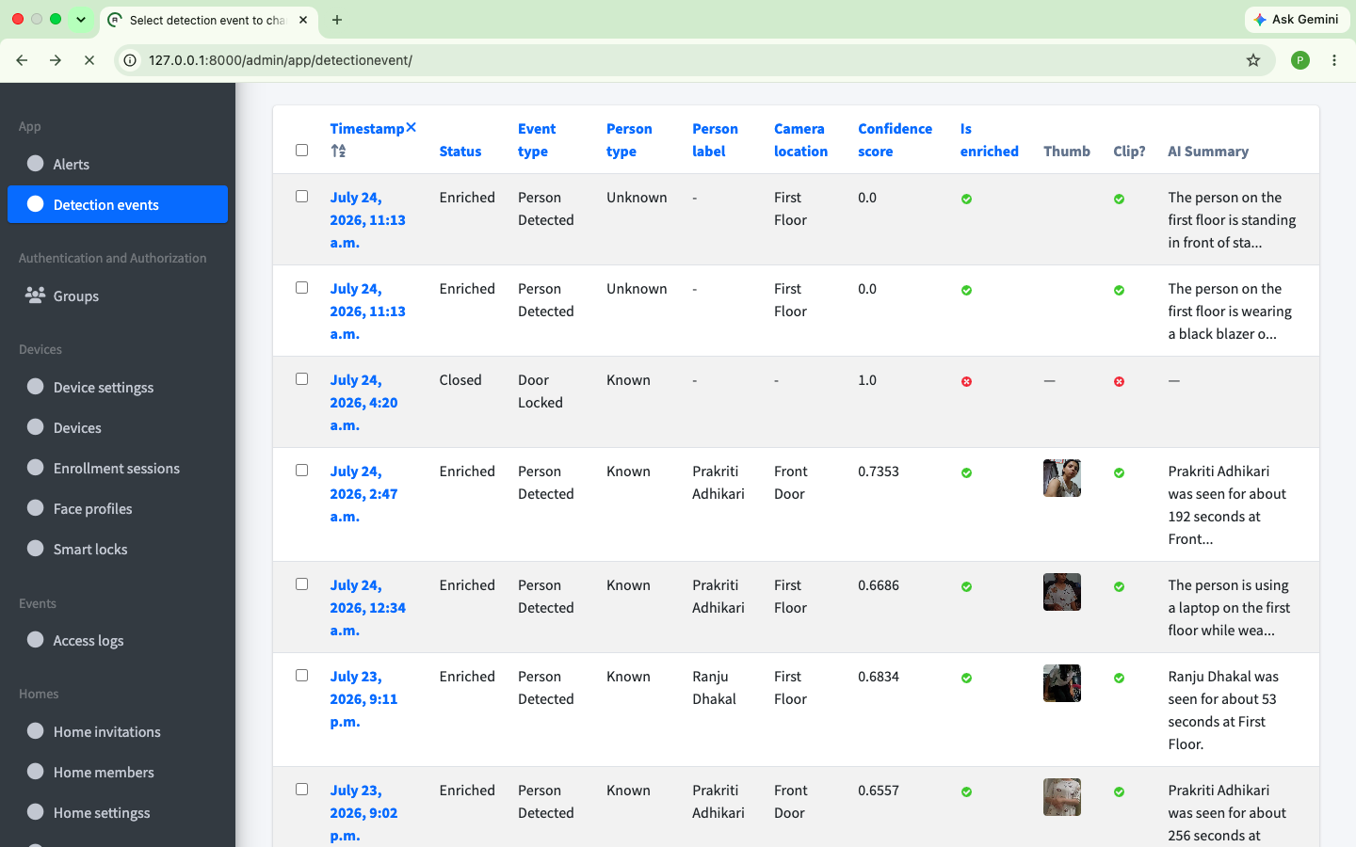

Figure B.2: Django Admin Detection Events Table

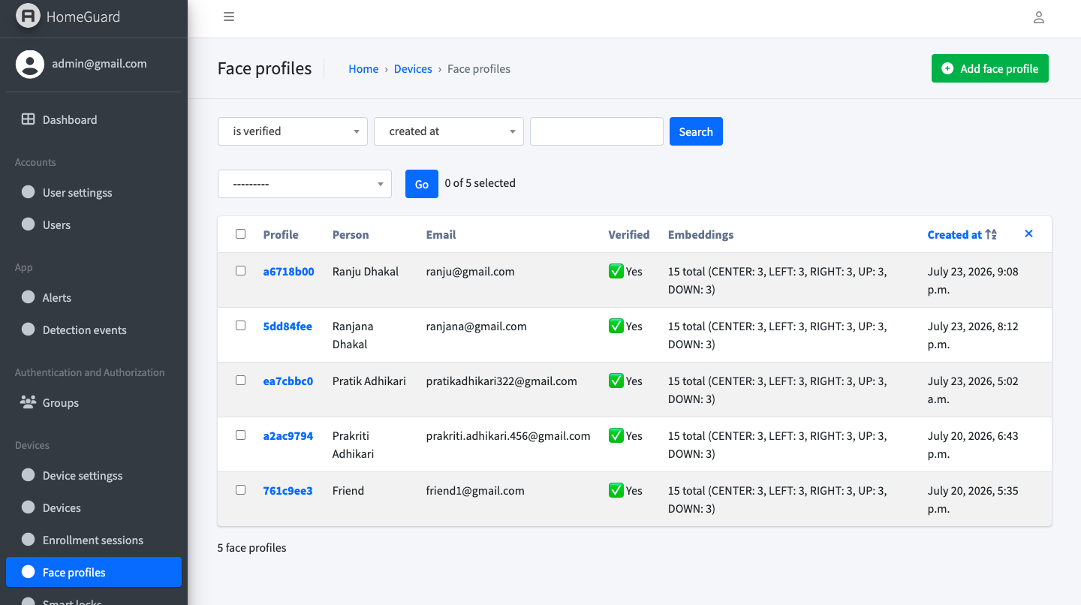

Figure B.3: Django Admin Face Profiles Database

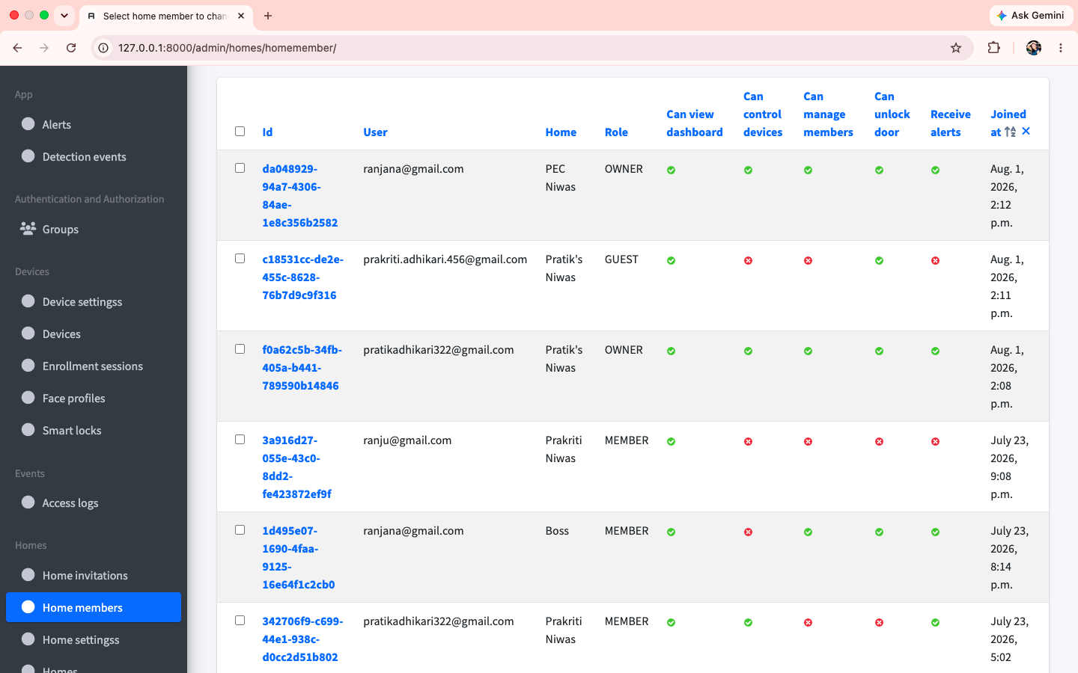

Figure B.4: Django Admin Home Members & Permissions Table

